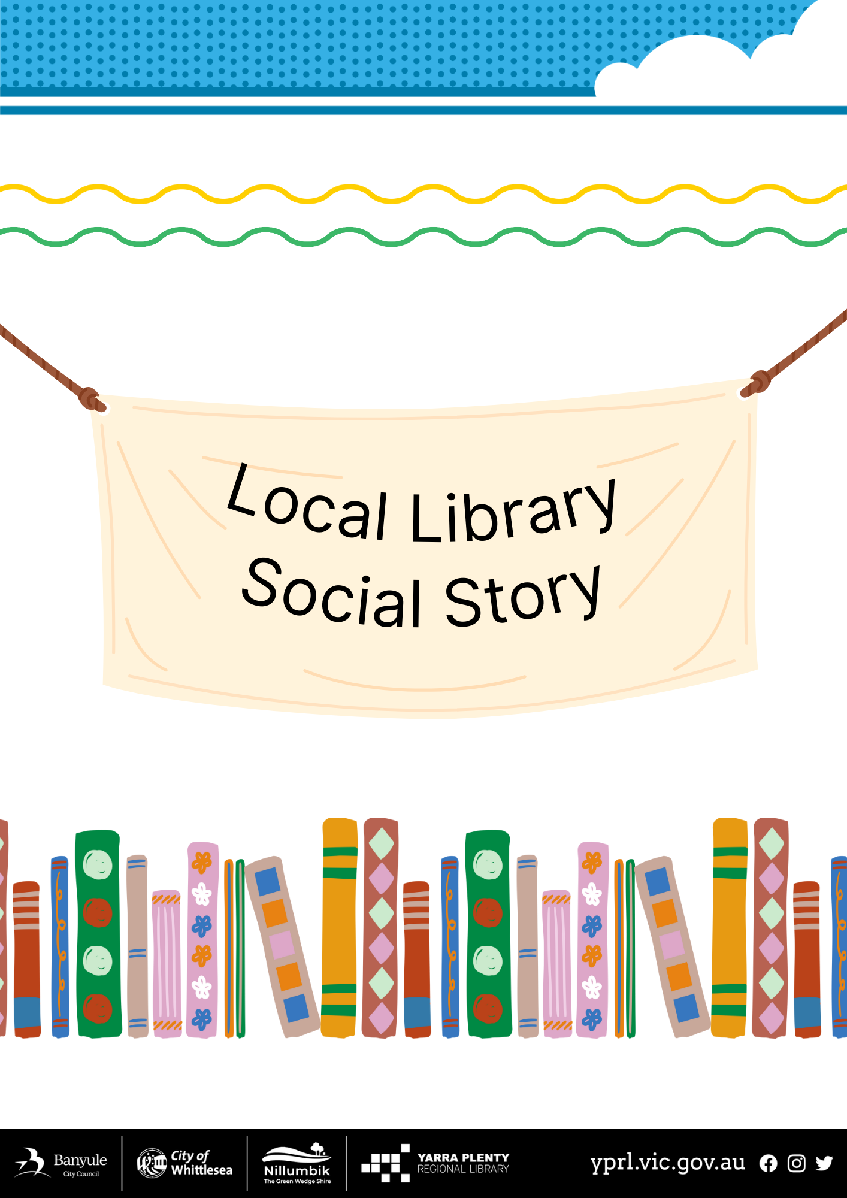

Social Story – My Visit to Rosanna Library

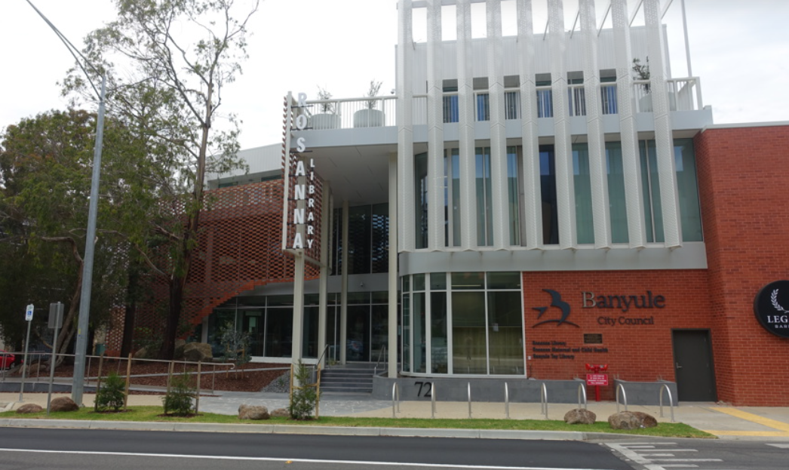

I am going to Rosanna Library.

I will go through two sets of doors to go inside.

The doors will open automatically when I get close.
When I enter, I will be in the foyer.
There is a desk where a librarian works.

The librarians wear nametags.  They are friendly and can help me if I have questions. | 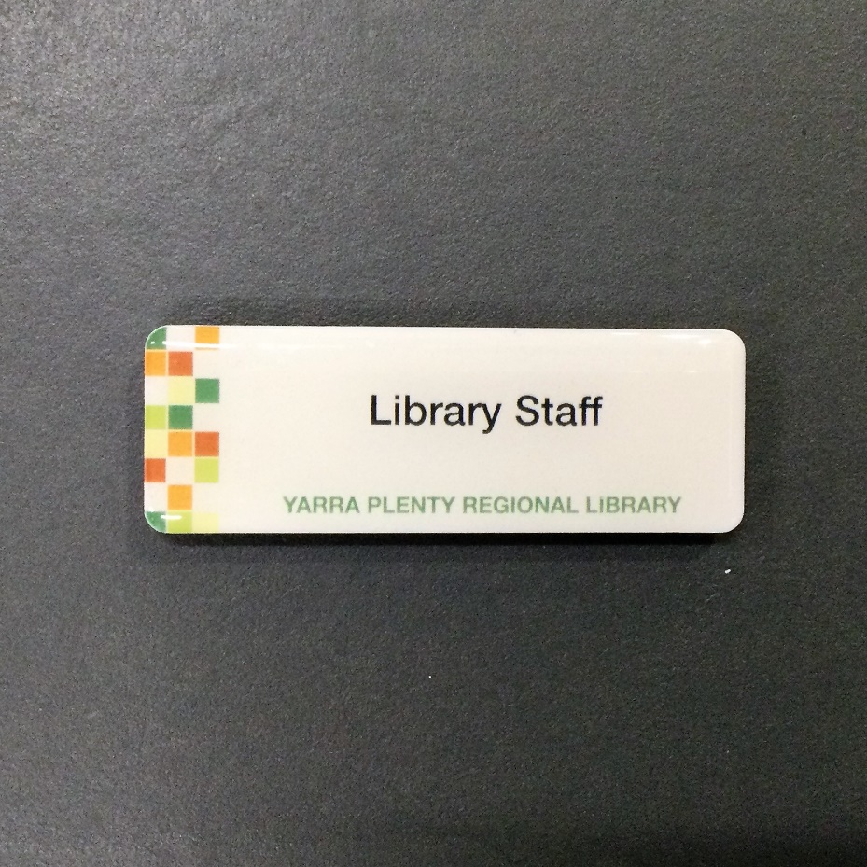
I can join the library and get a library card.
I need identification to join.

I can return books in the returns chute outside.

Reserved books are near the foyer desk and have my name on them.
for me, it will have a slip of paper with my last name on it.

There are many areas in the library.
I can choose where I would like to go.
There are 3 levels.
Ground, Level 1 and Level 2.

There are toilets on every level of the library.  The toilets on Ground Floor are just to the right of the stairs. | 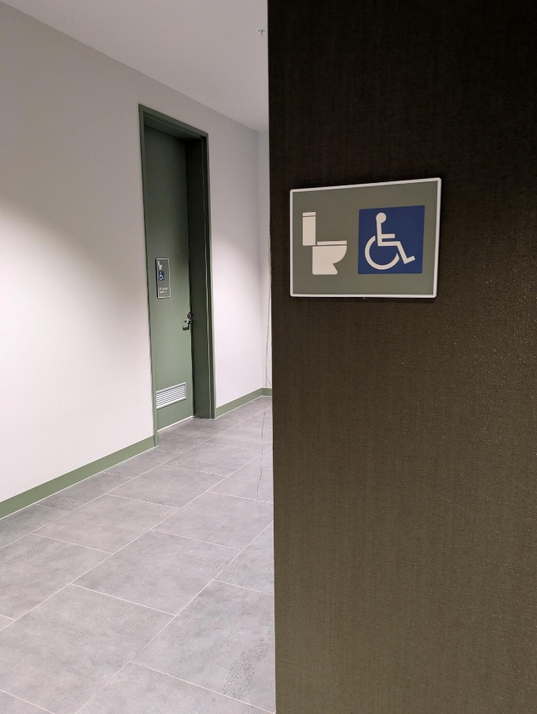
The children’s area is near the foyer.  Storytime happens here. It can be fun and sometimes noisy. | 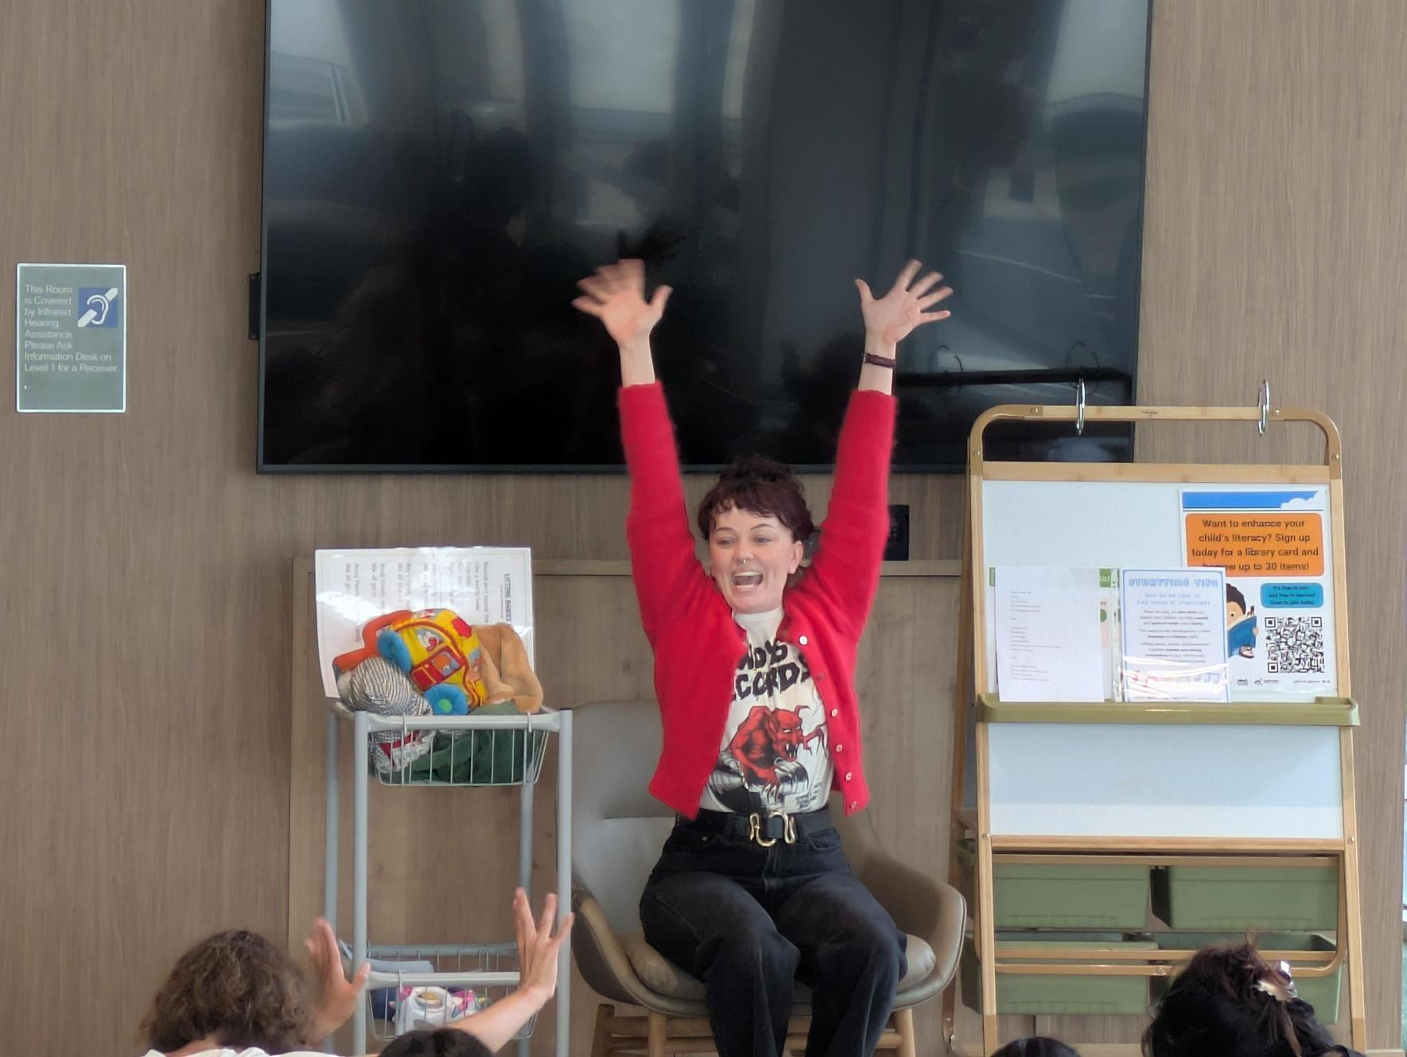
I can find many types of books, including: picture books
non-fiction books,
bilingual and read-along books.

I can go upstairs using the stairs or the lift.
I can move carefully and safely.

Upstairs on Level 1 I can find:  Adult fiction books, young adult books, comics and graphic novels. | 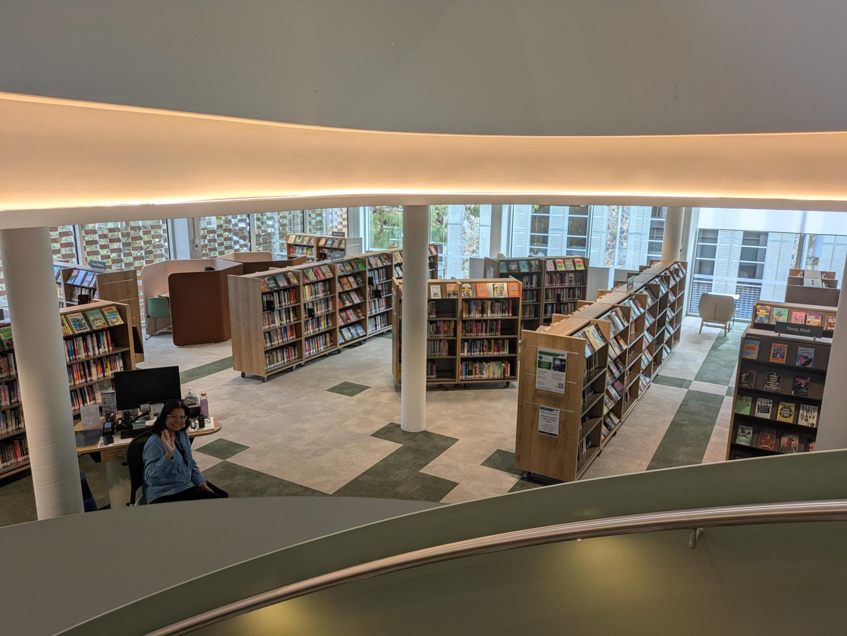
There are computers, printers, and photocopiers.
Some machines can be noisy. I can keep the volume low.

There are toilets, a drinking fountain, and places to sit.

There are also quiet study rooms. These need to be booked and library staff can help me with this.

The toilet on Level 1 is near the lift | 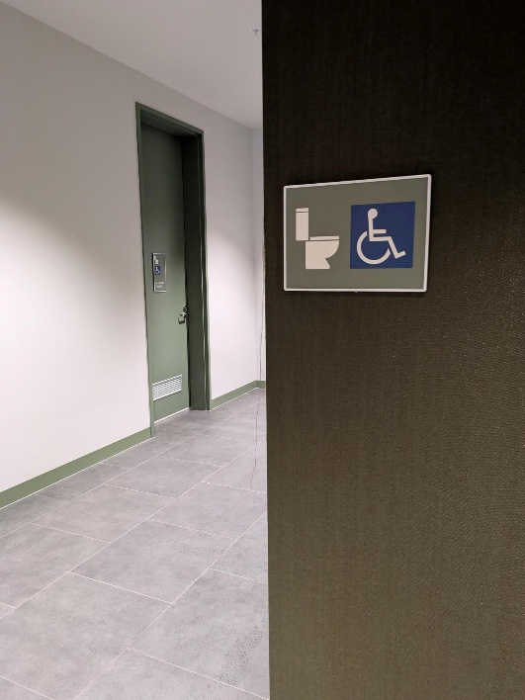
I can find a quiet place to read or study.

If I feel overwhelmedI can take a break or ask for help.

The library has spaces like a recording studio and podcast studio.  I need training to use these. | 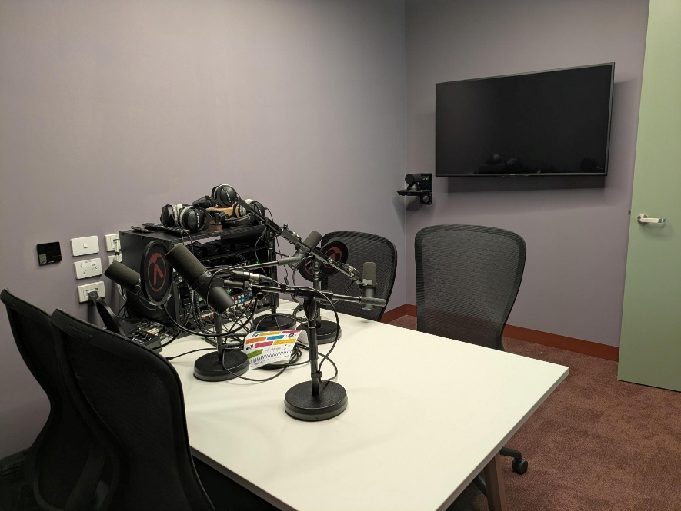
On Level 2 I can find newspapers and non-fiction books.
There are toilets on level 2, near the lift. | 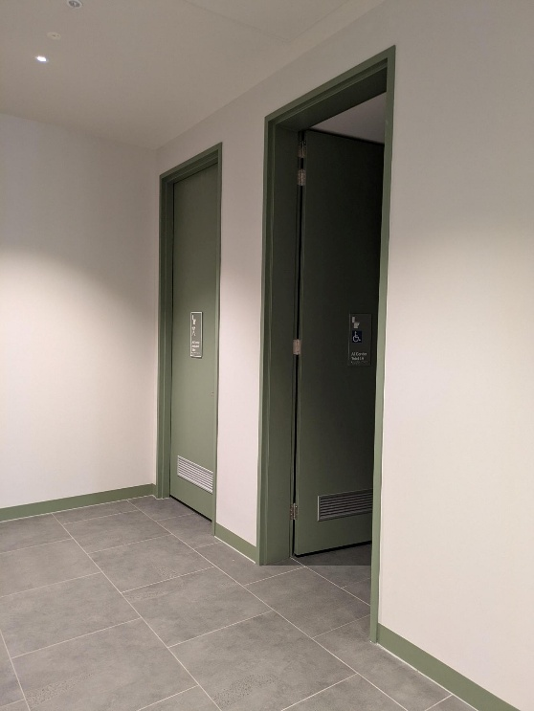
When I am finished, I can borrow items using the self-checkout.  When I leave, I can say goodbye to the librarians.  See you next time! | 