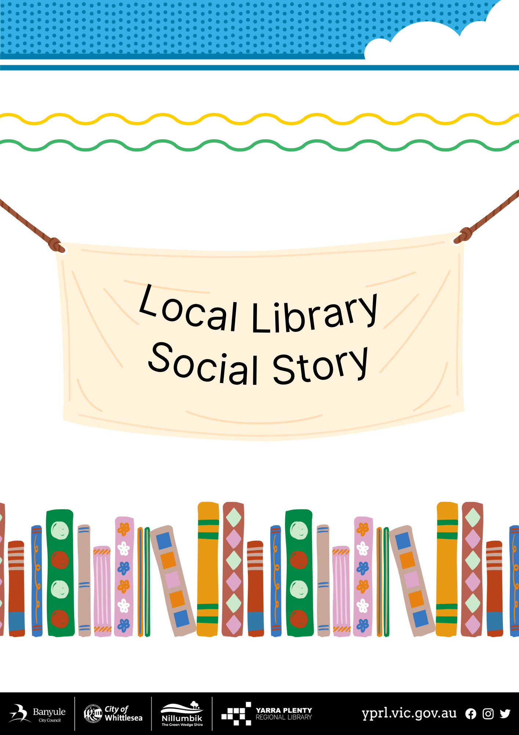
Social Story – My Visit to Rosanna Library Pop-up

I am going to visit the Rosanna Library Pop-up. | 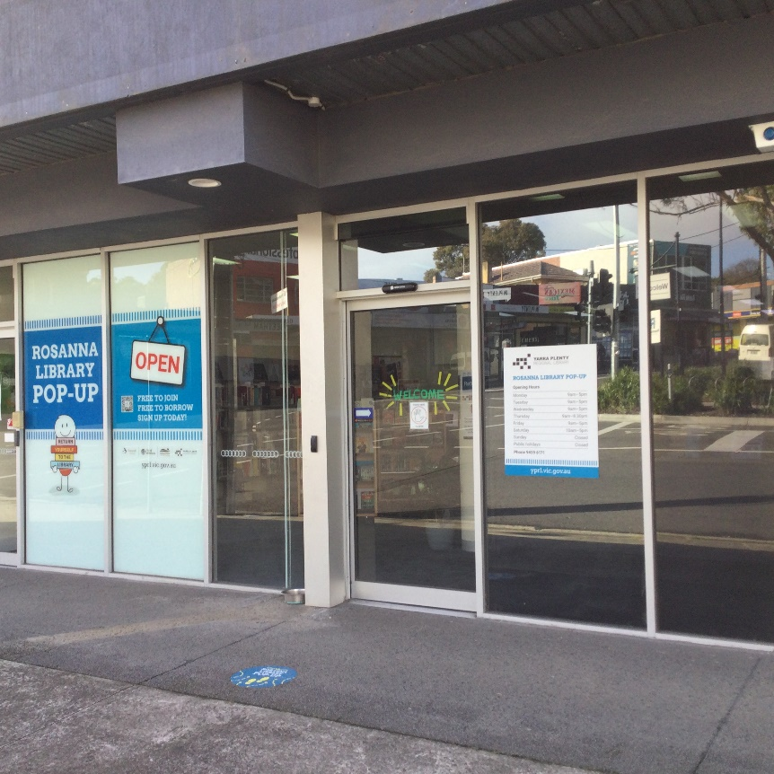
The door will open automatically when I get close. | 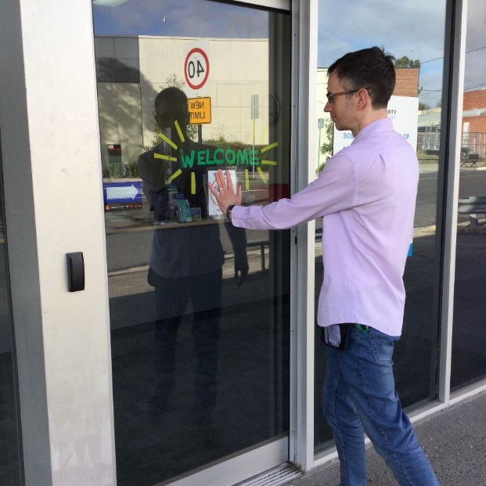
I can return my books at the front desk. | 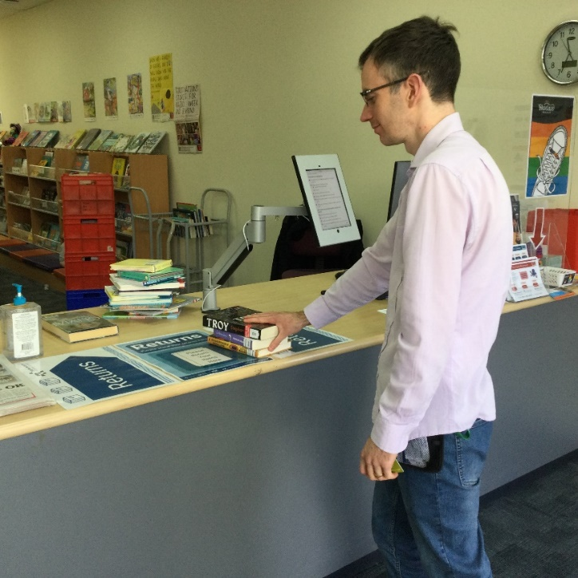
The librarians wear nametags. They can help me if I have any questions. | 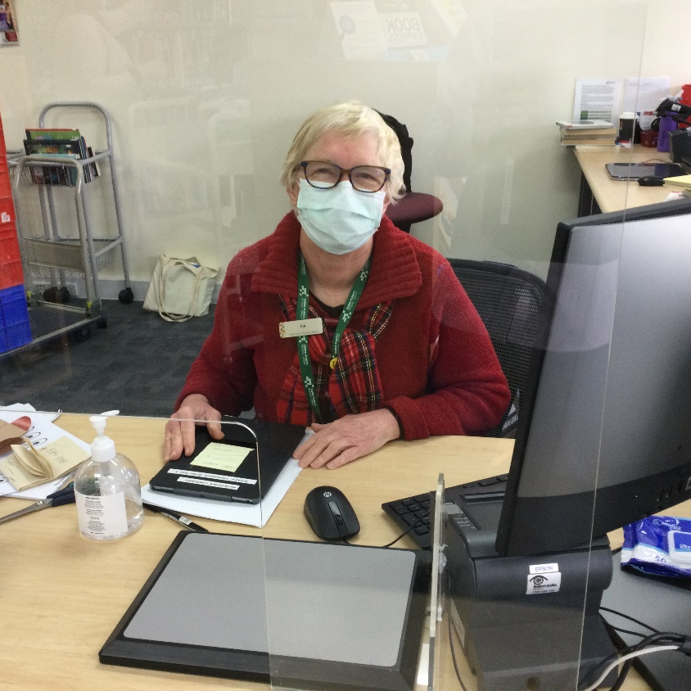
I can join the library at the information desk and get my own library card. | 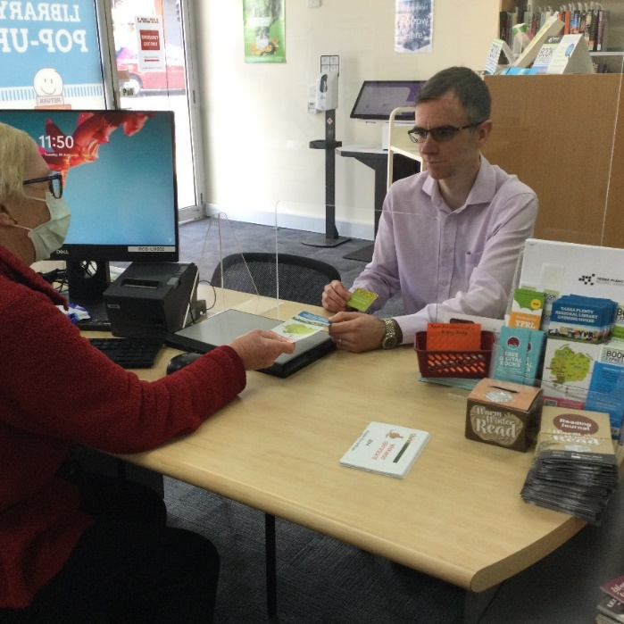
Books on reserve for people are on the left-hand side of the library. They are sorted by peoples’ last names. If there is a reservation for me, it will have a slip of paper with my name on it. | 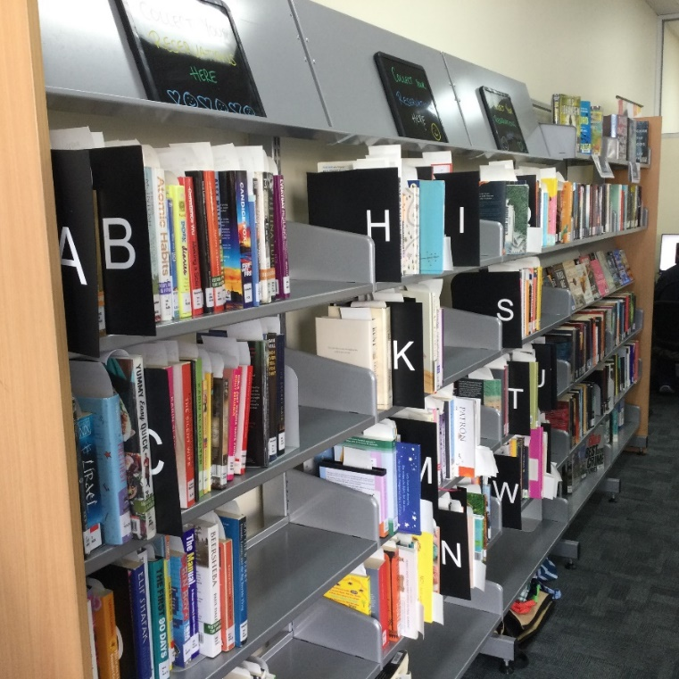
There are some shelves at the front of the library with new and popular books. | 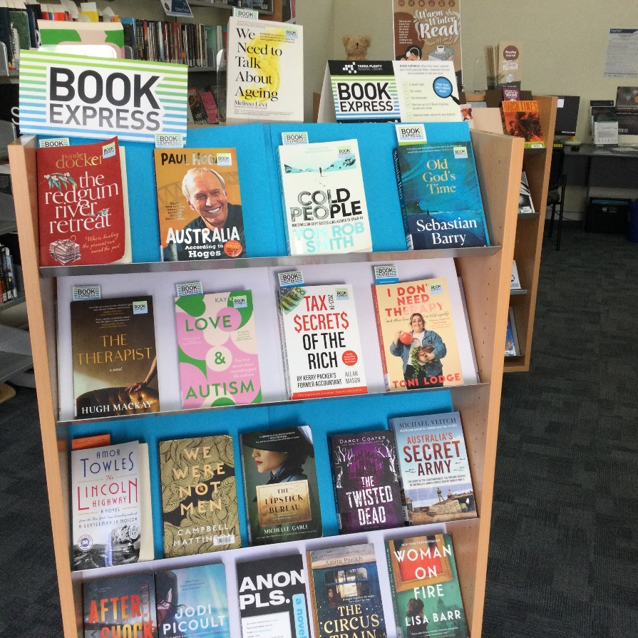
I can visit the children’s area and pick-out some books to borrow. | 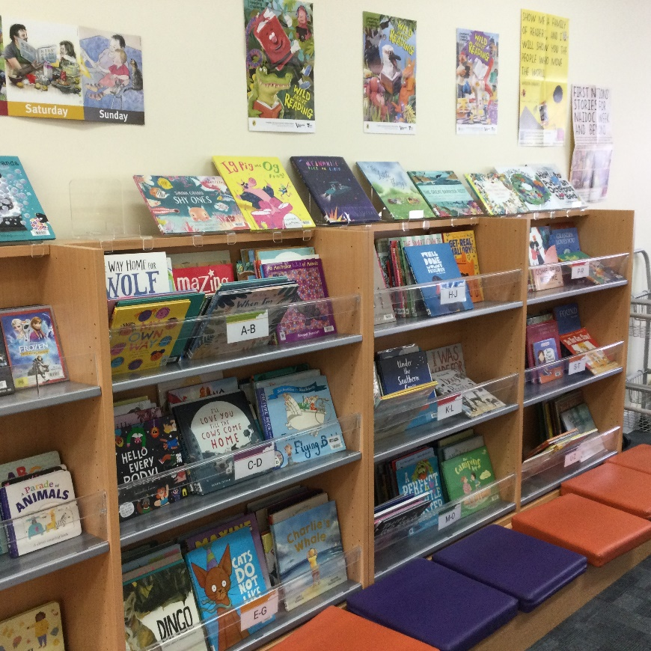
There is a photocopier in the library for people to print, photocopy and scan. It can be noisy when in operation. | 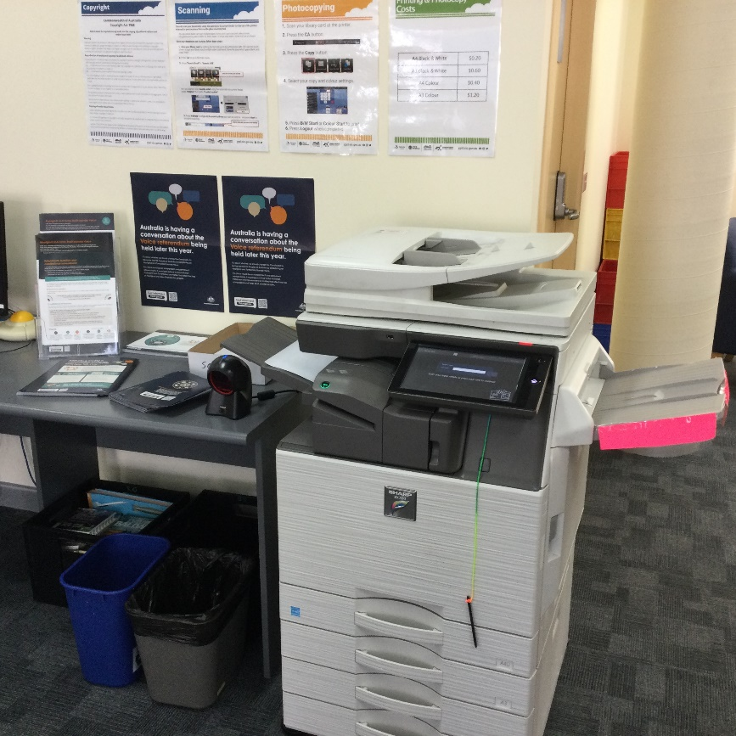
There are 3 public computers that people can use to access the internet. | 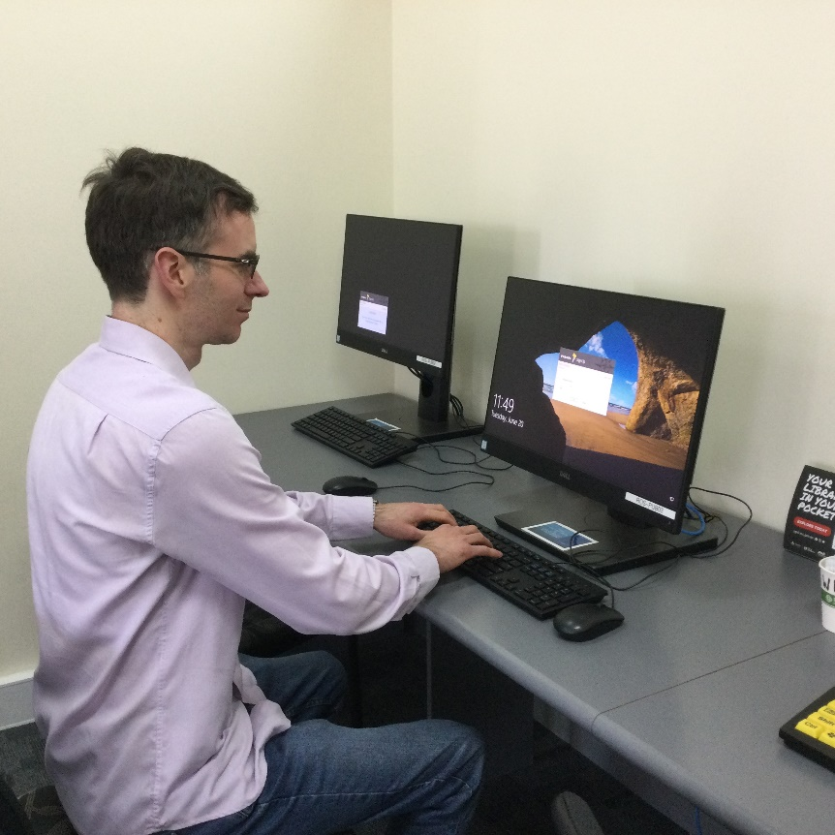
There is free Library Public Wi-fi that I can use to access the internet on my own device.
There are some tables and chairs at the back of the library. I can sit quietly and read here.  There are today’s newspapers as well. | 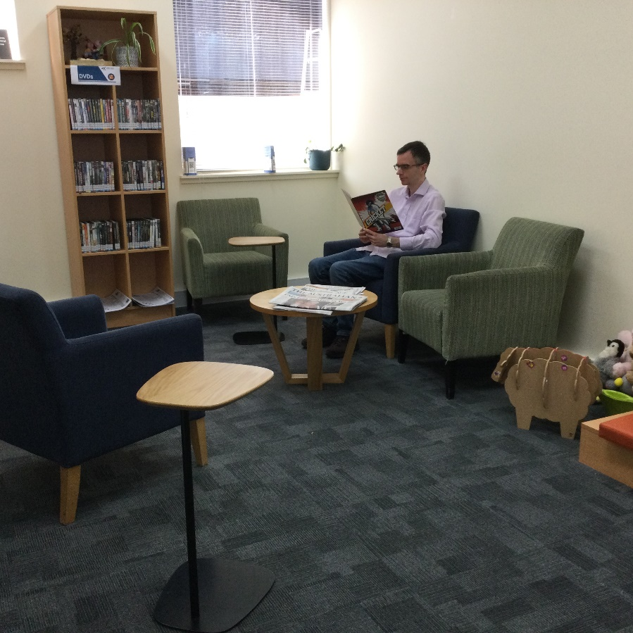
There are some toys I can play with or cuddle if I feel overwhelmed. | 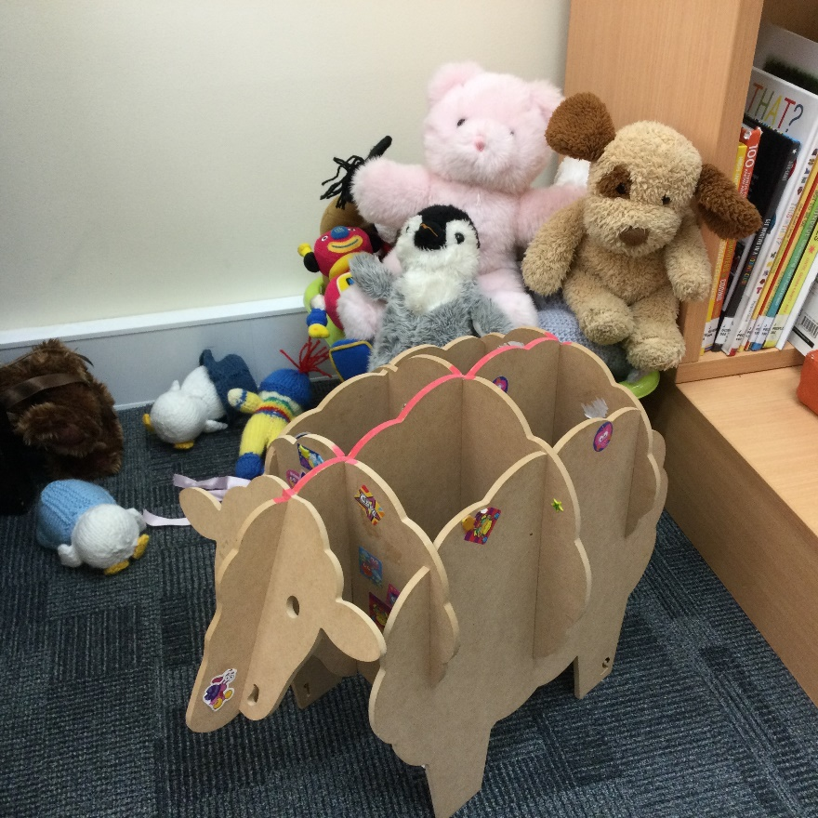
I can borrow items myself from the self-checkout machine. | 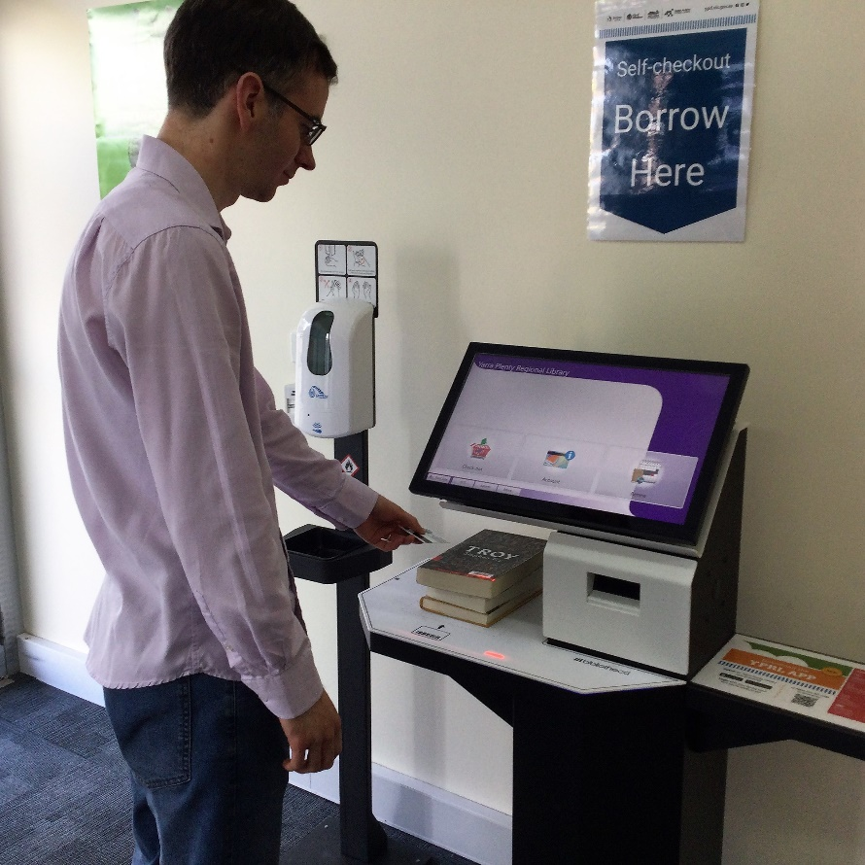
There are no public toilets. I can use the toilets at the Rosanna railway station instead. | 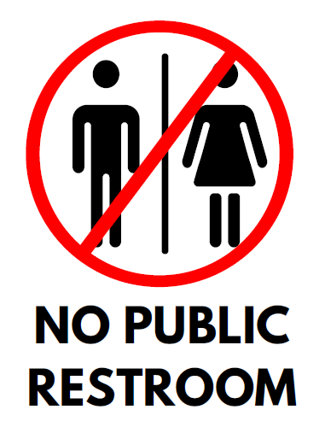
When I leave, I will say good-bye to the librarians. | 