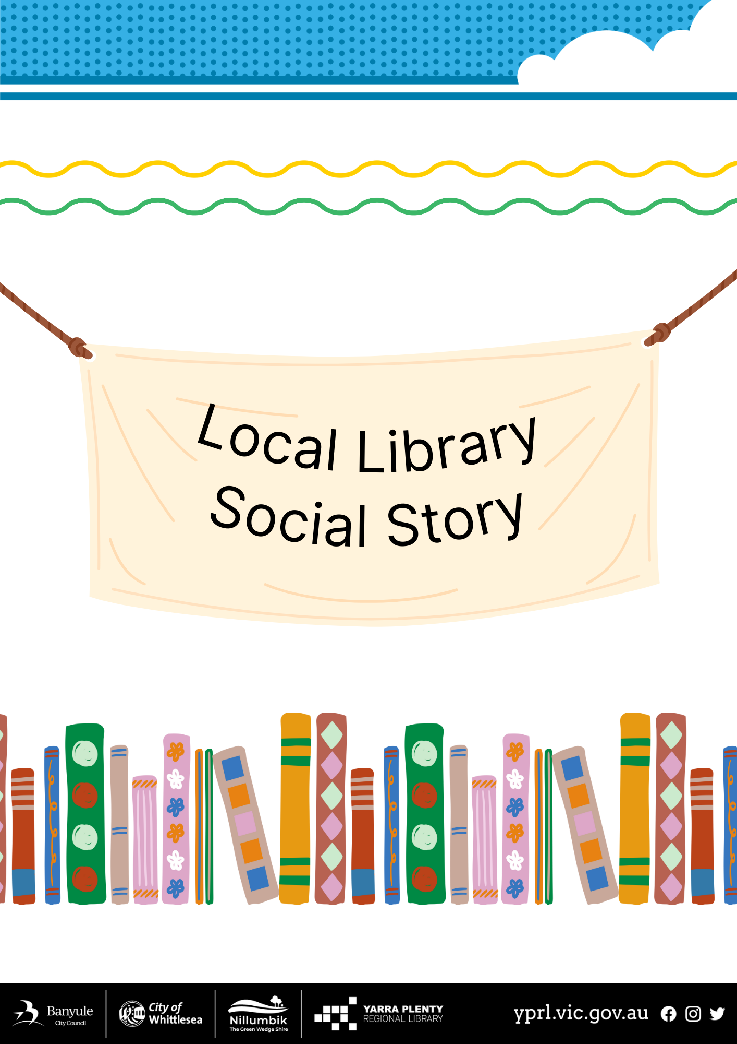
Social Story – My Visit to murnong Library
I am going to visit murnong Library today, there are steps and an access ramp to the main entrance. | 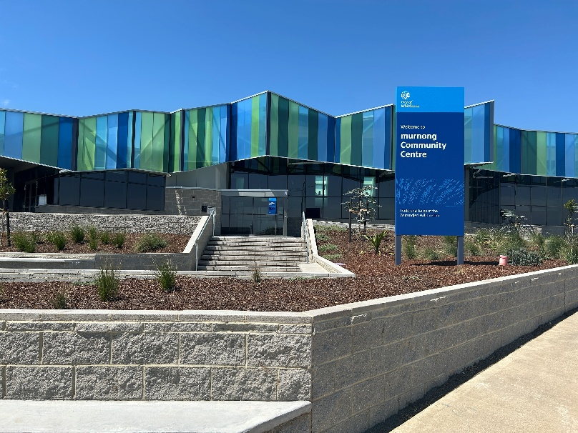
There is a book return chute on the left-hand side of the entrance where I can return my books. | 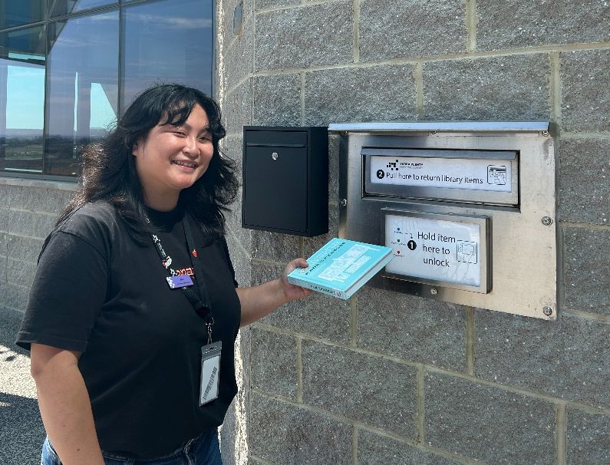
There are two automatic doors that lead me inside. | 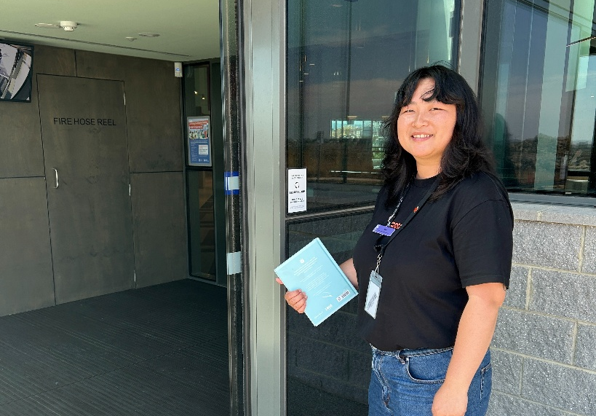
A librarian can help me at the front desk. | 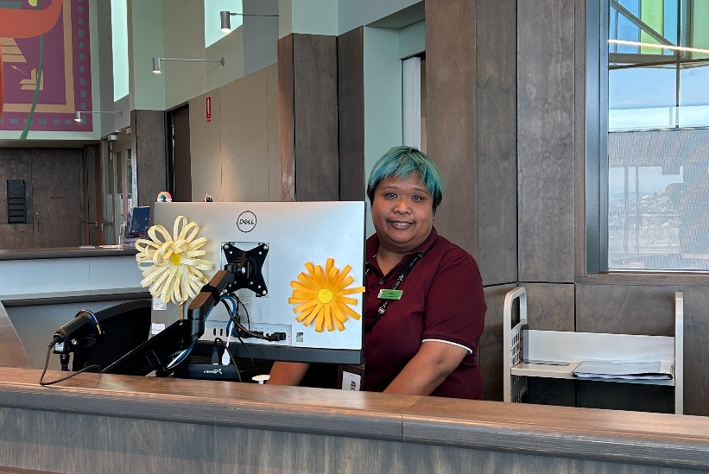
I can ask questions at the front desk or get my own library card. | 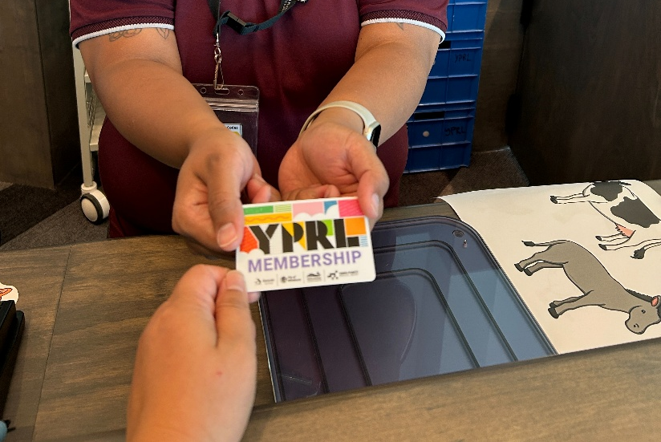
There are lots of books on shelves to look at. | 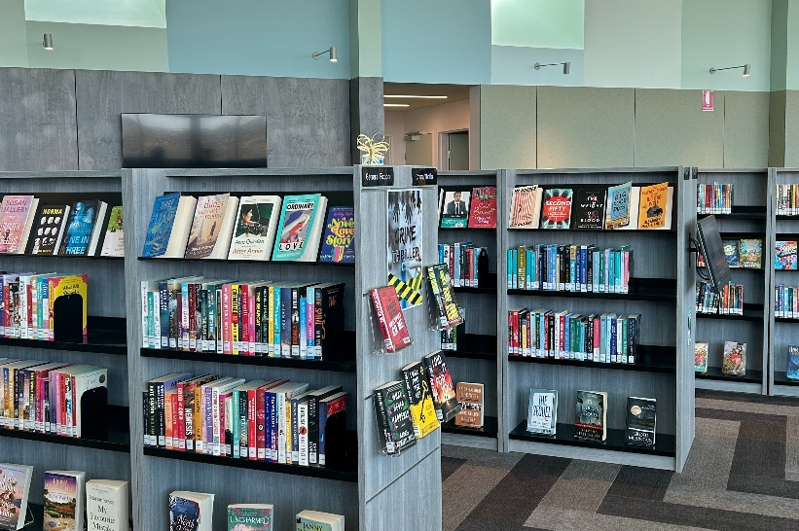
There is a children’s area with lots of picture books. | 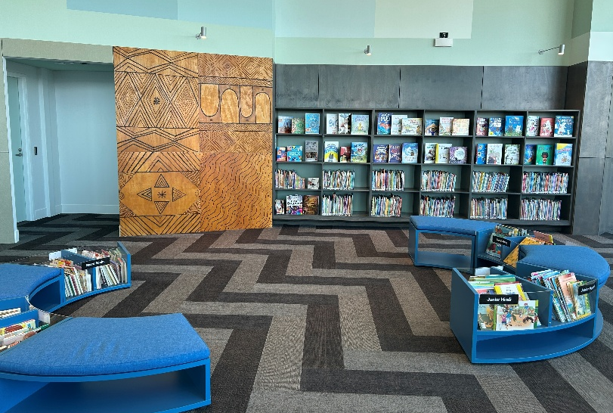
There is a shelf for books on reserve for people. I can collect my reservations here; it will have a slip with my name on it. | 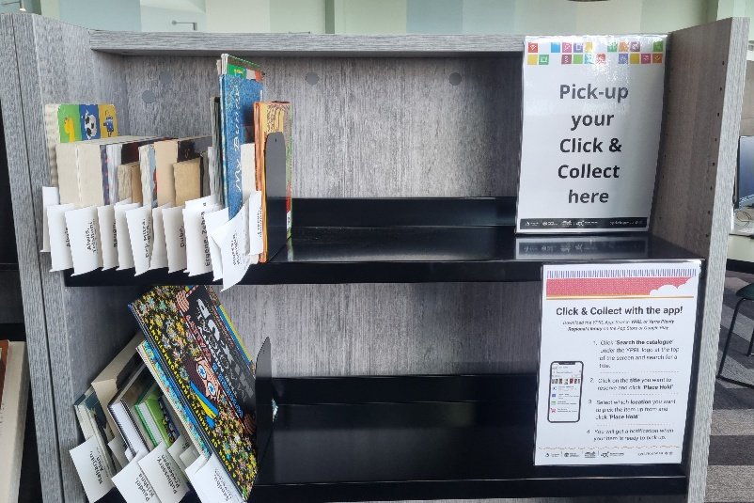
There are desks and chairs where I can sit down and read. | 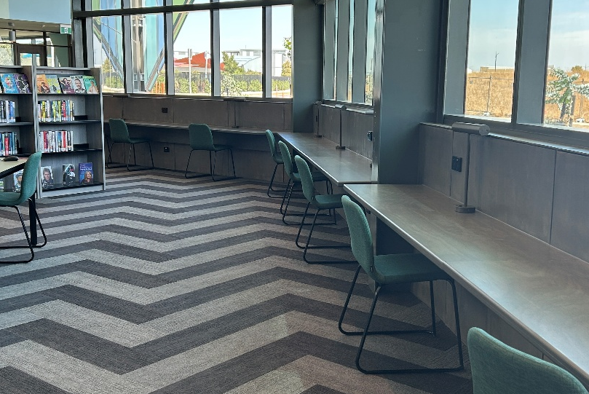
There are public computers that people can use to access the internet. | 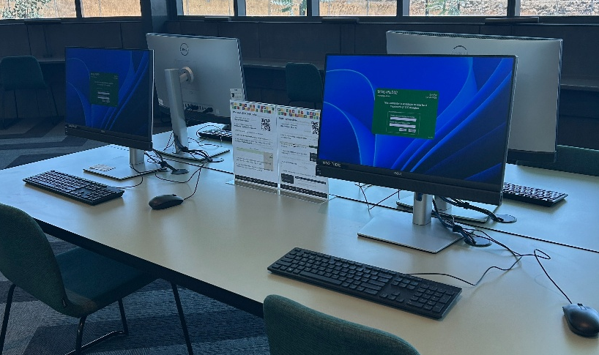
There are public toilets. These toilets are for all genders and there is an accessible bathroom and family change room. | 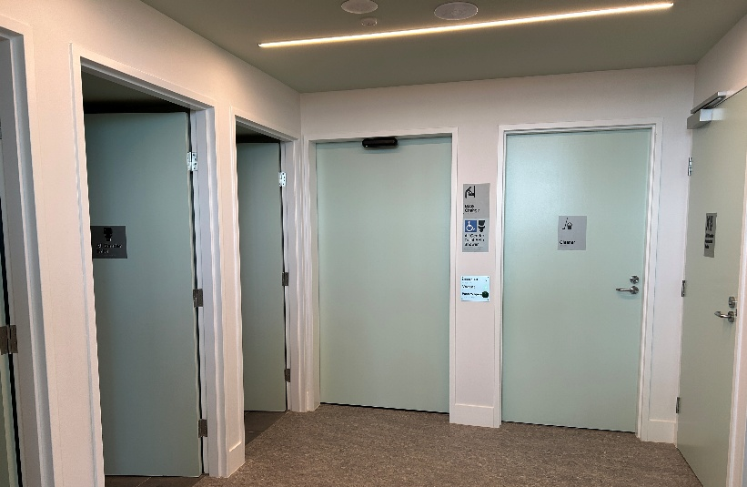
There is a photocopier  in the library for  people to print,  photocopy and scan. It  can be noisy when in  operation. | 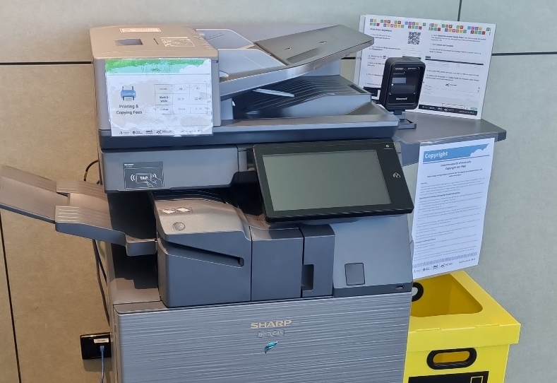
There is a kitchen for people to use with a microwave, bin, a fridge and a tea and coffee station. | 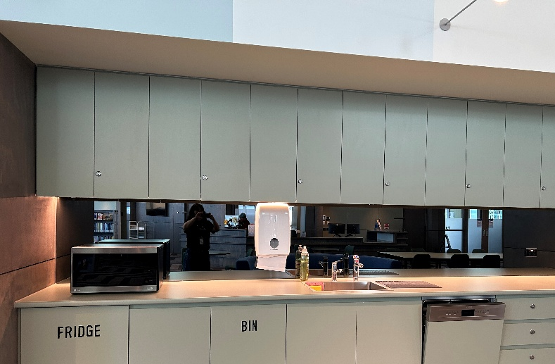
I can borrow items myself from the self-checkout machine by the entrance. | 