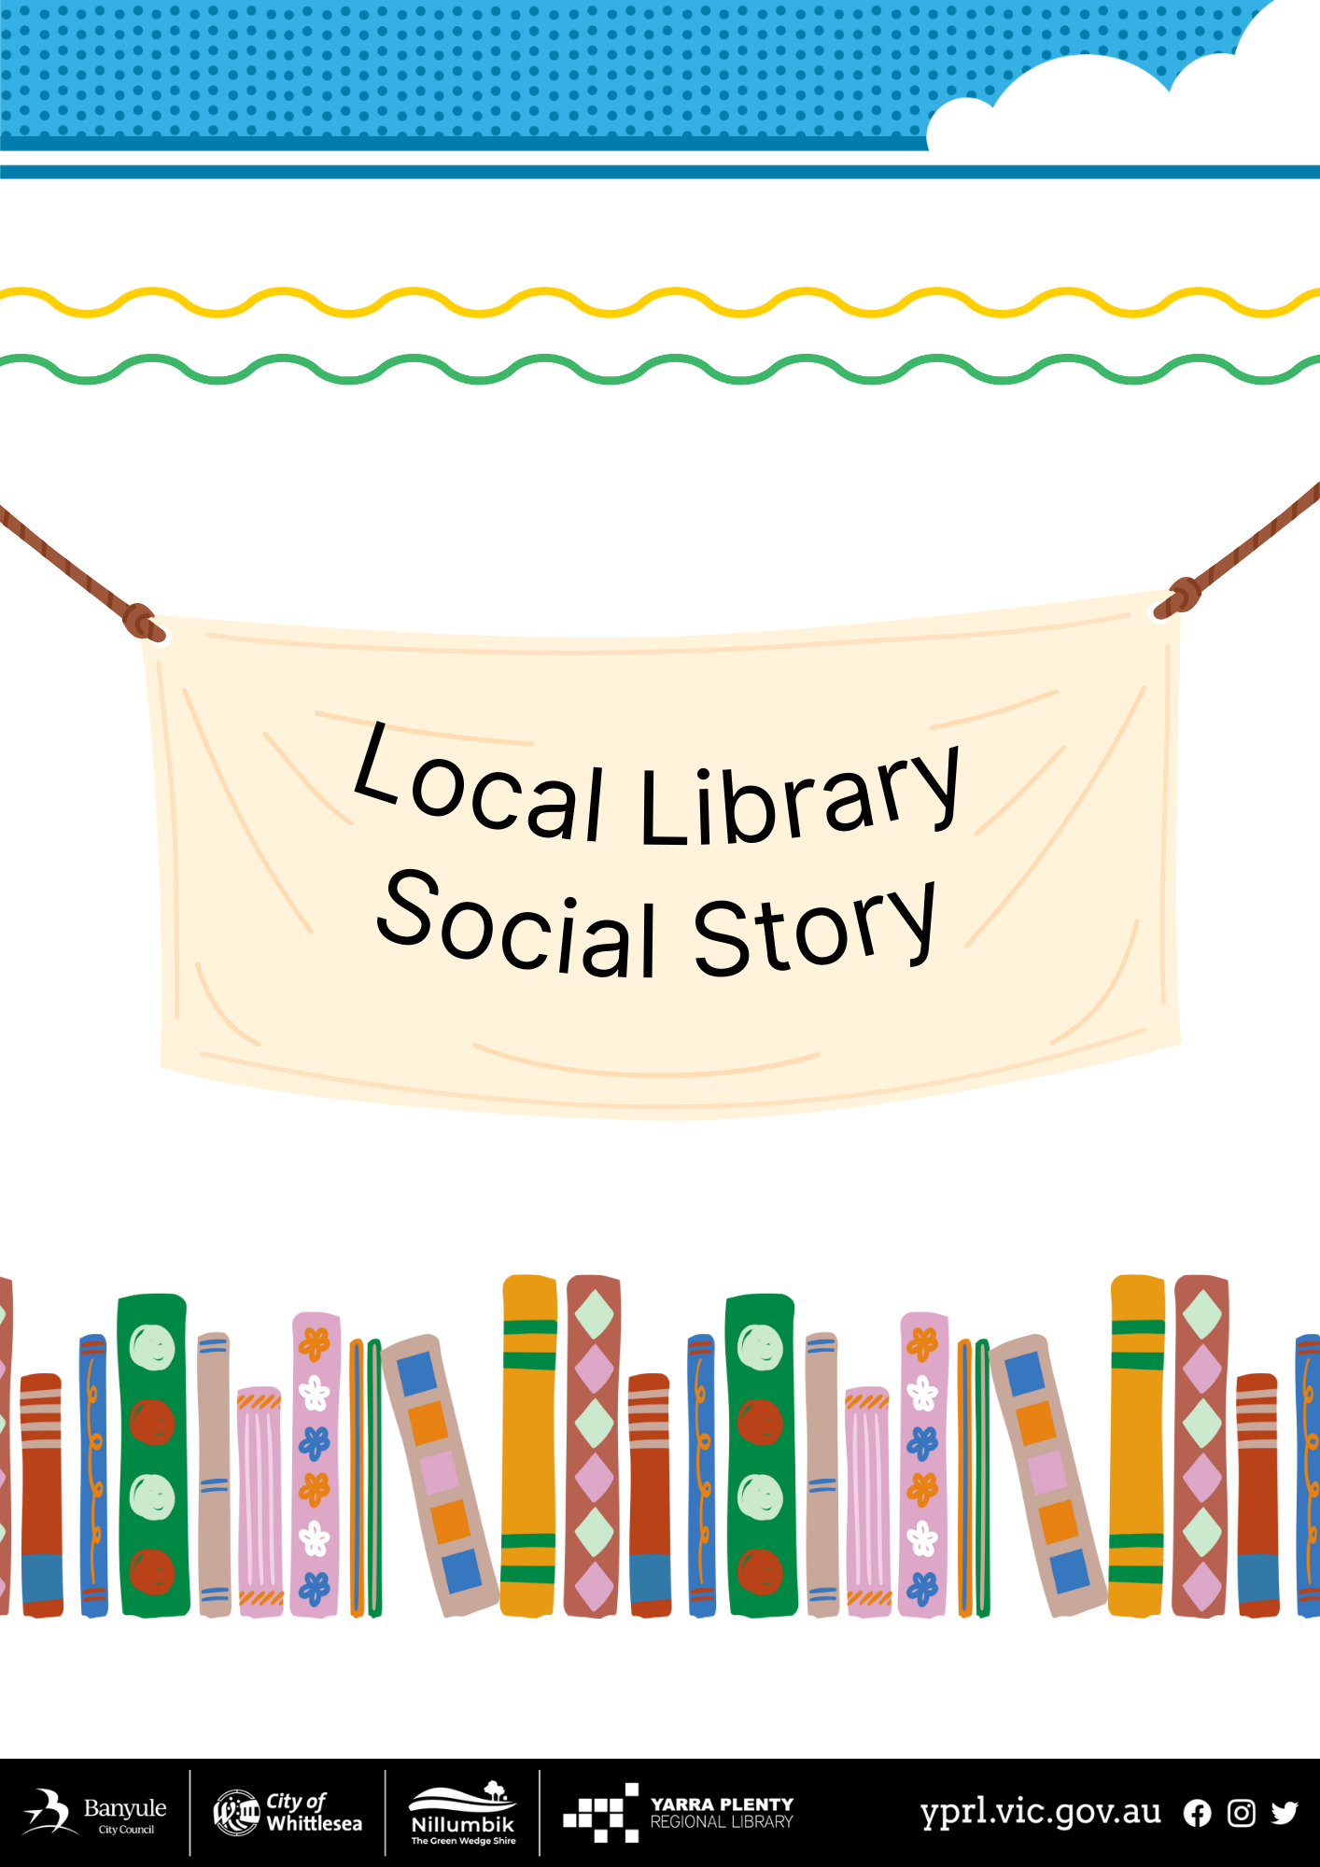
Watsonia Social Story
Welcome to Watsonia Library.  The library has two entry points. The most common is from the car park side. The other side has one 2-hour accessible parking space and is a quieter street. | 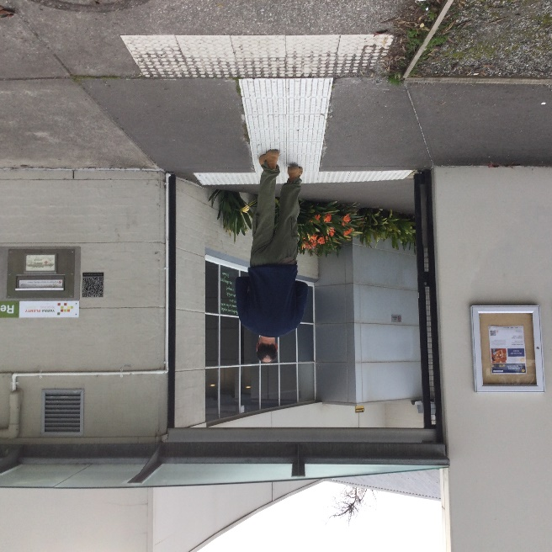
To the left-hand and right-hand side of the entry there are two accessible toilets which are large and can be used by everyone. | 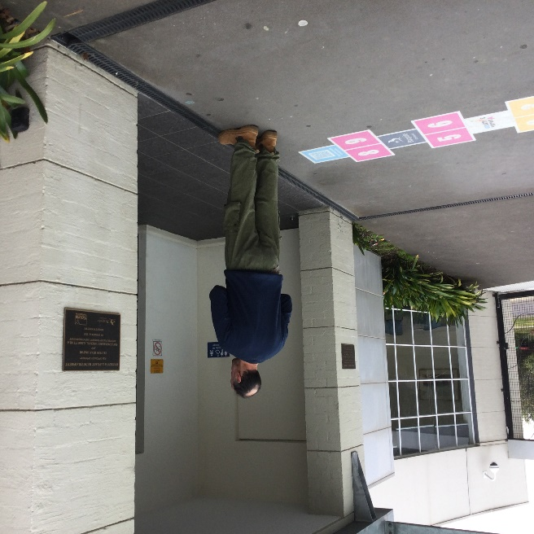
When entering the building there are two sets of automatic doors to walk through.  After the automatic doors you pass through the security system which could make a loud noise if someone forgot to borrow a book.  The building will open into a larger space. | 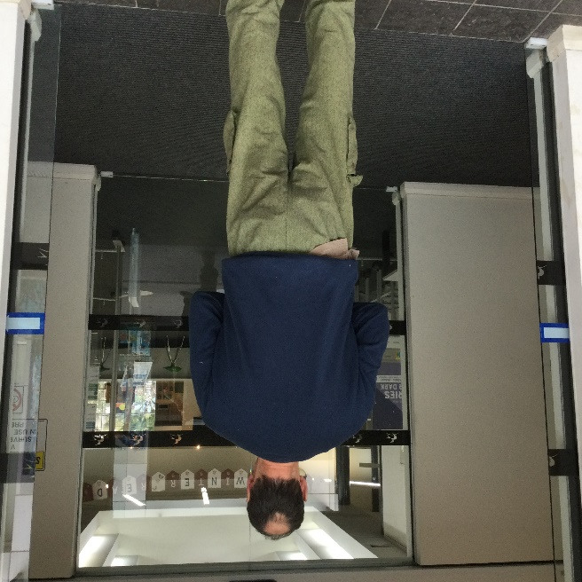
Watsonia Library is an open plan building and is well lit with the natural lighting from the windows. There are also electrical downlights.  Ahead is the Lab Bar, which the public can access for studying, talking, reading, or playing chess.  To the right is the Information Desk. | 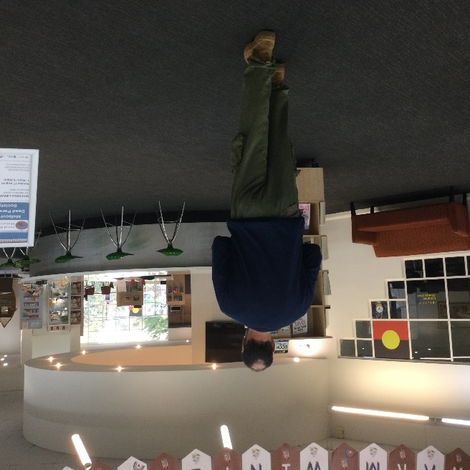
This is the Information Desk. This is where you can get staff assistance and join the library.  The staff can assist in answering reference questions, help with returning books, computers and printing, and general enquires. | 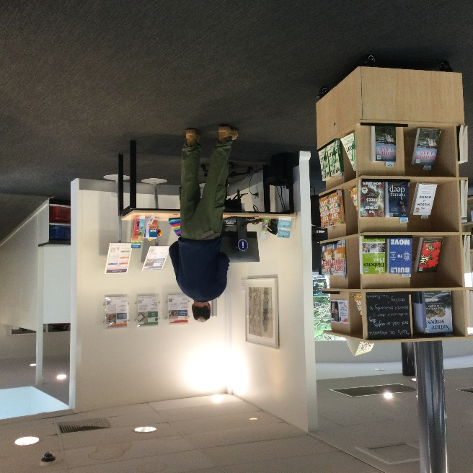
The children’s area is around the corner from the main part of the library.  All Junior books, DVDs and audio books are kept here. YA fiction and graphic novels are also in this area.  You can access the garden through the glass doors, which is a quieter area to sit. | 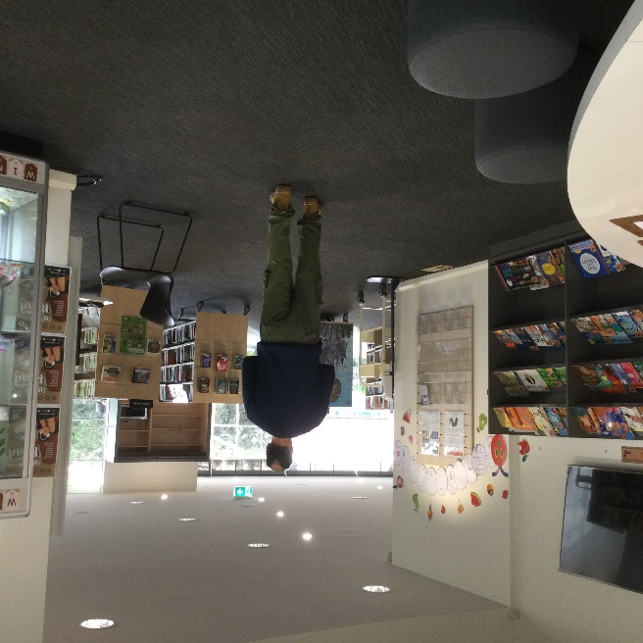
In the mornings the children’s area can be noisy and crowded with families attending story times.  The open plan nature of the building also allows for sound to travel.  Between 12pm and 3pm this area is quieter. | 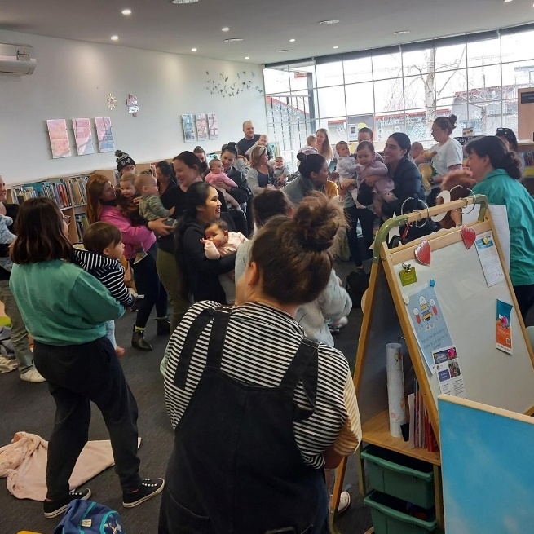
You are welcome to borrow books anytime the library is open.  You can use your plastic library card and the self-service machine, or use your mobile phone and our app.  The library staff will help with any questions you have about borrowing. | 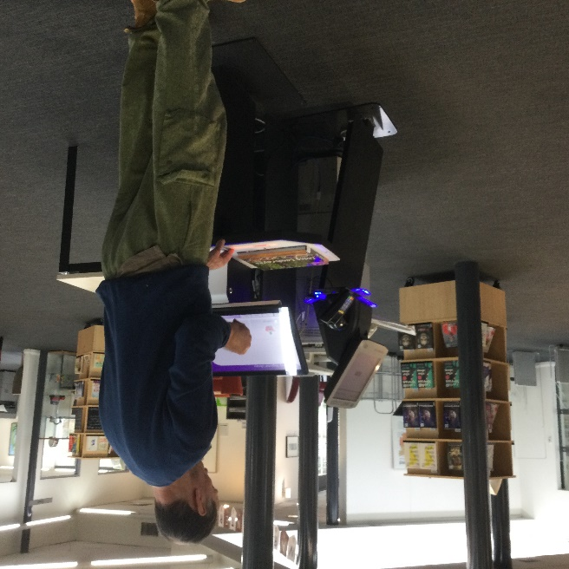
The Quiet Reading Room is a lovely space to read or study in silence.  Walking through the entry under the clock.  Here there are two additional toilets, one male and one female. | 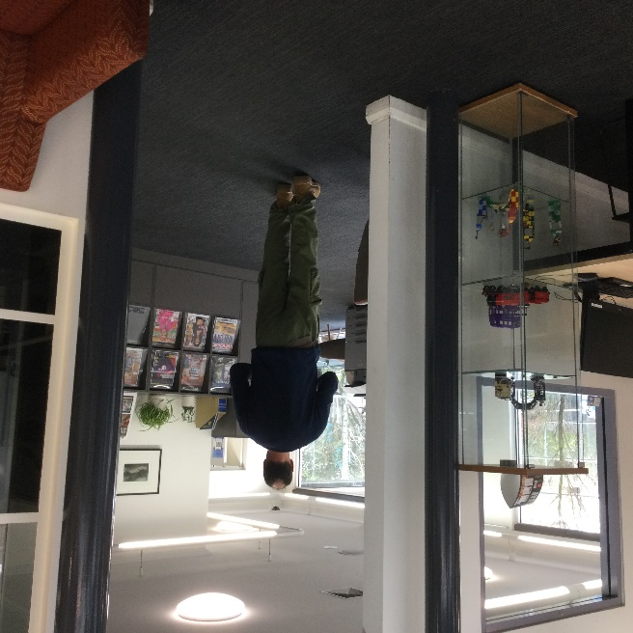
Continue past the magazines on the right and you enter the Quiet Reading Room. | 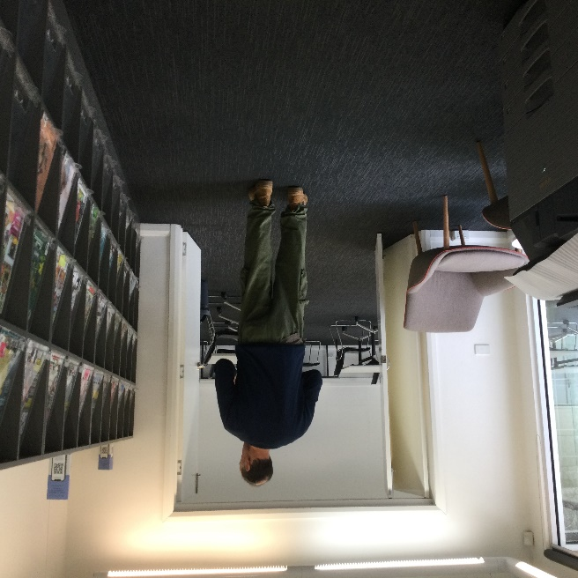
This room is a bright and clean space to read or study.  There is no talking or group work in this space, whether it is face to face or a mobile device. | 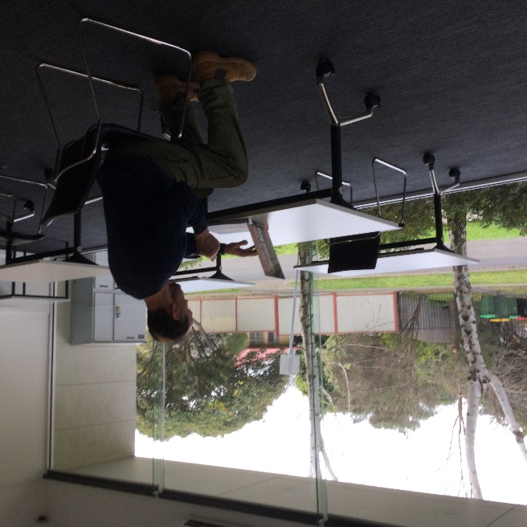
Exiting the building is the same way as entering the building.  First the security system which could make a loud noise if someone forgot to borrow a book and then the two sets of automatic doors.  We hope to see you again soon at Watsonia Library. | 