Whittlesea Library Social Story
Whittlesea Library is located in a Community Activity Centre, there is a large automatic door at the front of the building. The doors open when you get close to them. They will close once you have walked through and moved away from them. | 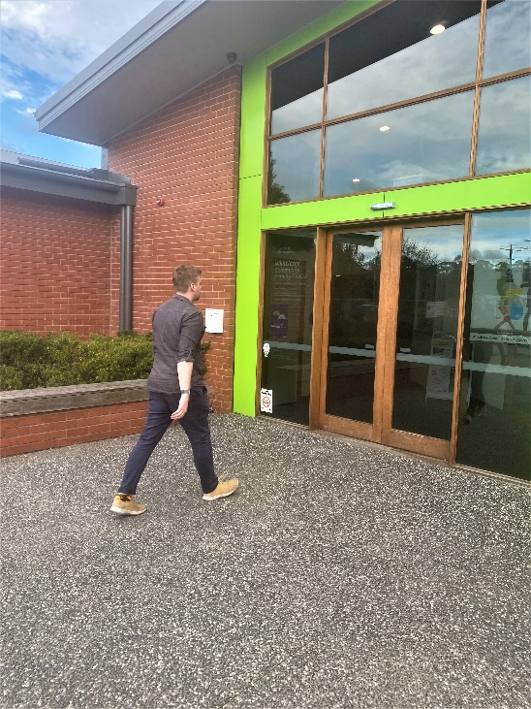
When you are inside, there is a long corridor. | 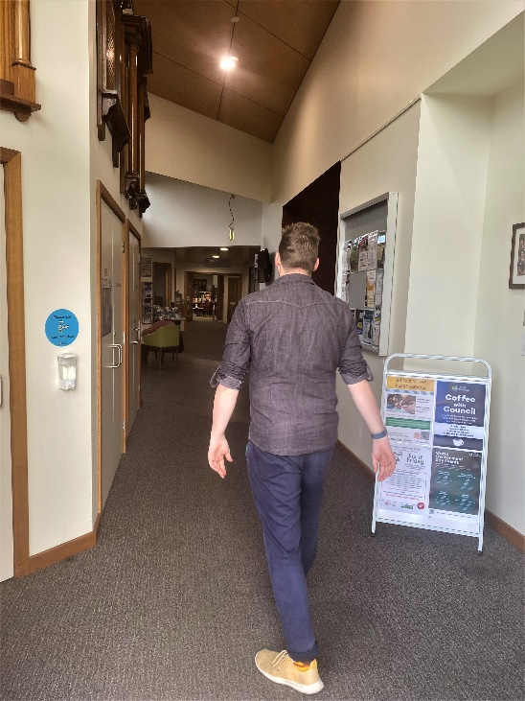
On the right-hand side there is a large room called the Memorial Hall. This is used by people for activities such as exercise classes, lunches, parties, dancing. Sometimes there are up to 100 people in there so it can be quite busy and noisy. | 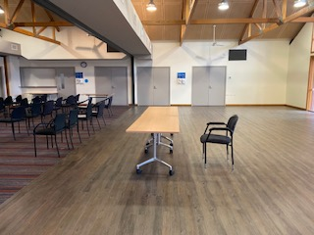
On the left-hand side of the entrance there is a small kitchen where the council provides tea and coffee for free. You can help yourself if you want to. There are some chairs you can sit on too. | 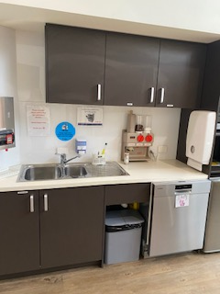  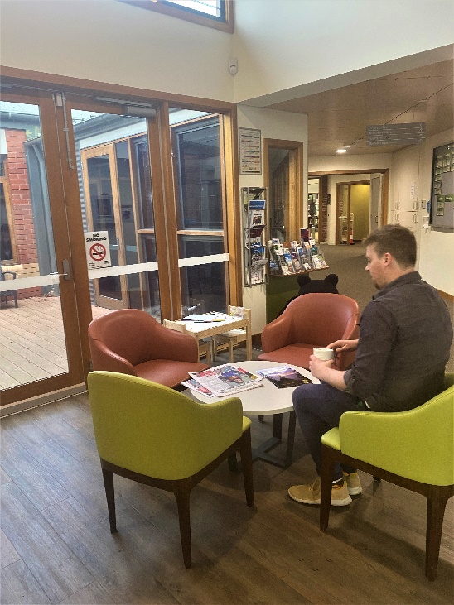
Behind the kitchenette there are 2 meeting rooms. These are used for meetings, sewing classes, or studying. They are smaller so will have fewer people in there. | 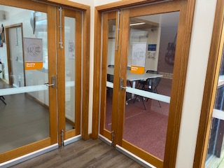
Walking up the corridor, you will see a council office on the right side. There may be council staff working there. You can say hello if they are not busy. | 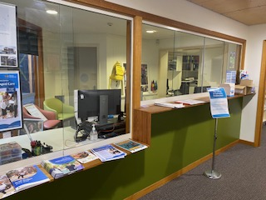
At the end of the corridor to the right is another corridor with toilets that the public can use. These toilets have hand dryers which are noisy.  At the end of that corridor is a commercial kitchen where people sometimes cook. You may be able to smell yummy food being cooked for a private group. | 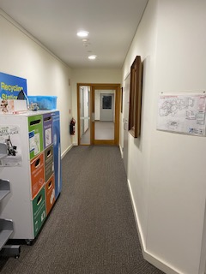
You will have seen the entrance to Whittlesea Library straight ahead. Welcome!  Just outside this entrance are books that have been reserved, waiting for borrowers to collect. | 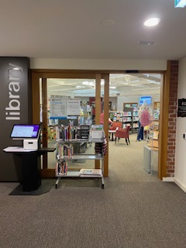
Inside the library there are tall shelves with non-fiction books (along the wall) and fiction books (in the middle). Other people may be looking for books to borrow on these shelves. | 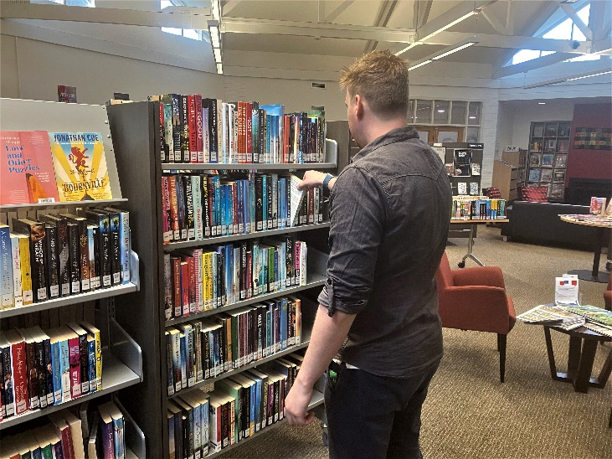
Along the side walls are some computers. People use these to work, study, play games. Usually people use headphones if they are watching something noisy but sometimes they forget. | 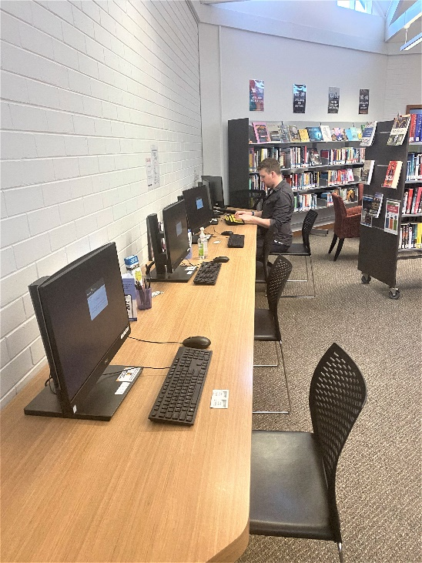
There is a heater with some chairs you can sit on. If it is a cold day it is a relaxing quiet place to rest. People sit here and read newspapers, magazines, and books. | 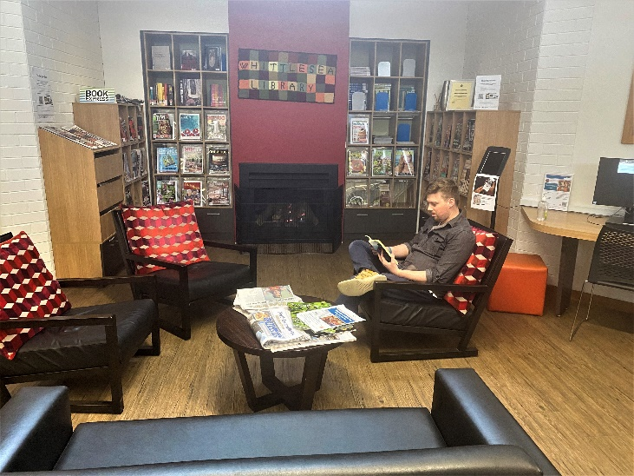
You will see library staff walking around, putting books on the shelves, and talking to other people in the library. They wear lanyards or have name tags pinned to their clothes, so you know they are staff. You can ask them for help if you need to (or just have a chat). | 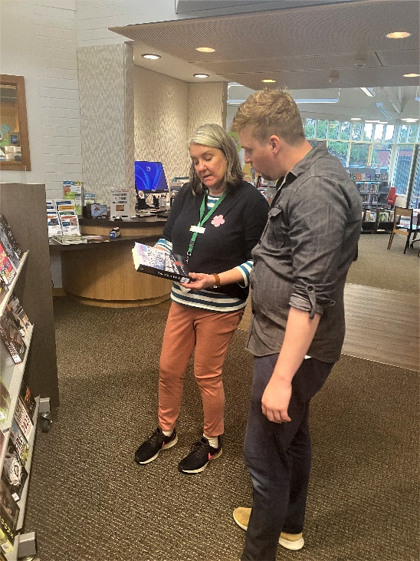
Towards the back of the library there is the children’s library. There is a table and chairs set up where you can do some colouring in or craft. Sometimes people meet here to have a group discussion – it may be seniors participating in a reminiscing program, or carers having a catch up. If they are there you may not be able to do colouring in, but the library staff can help find you another place to do it. | 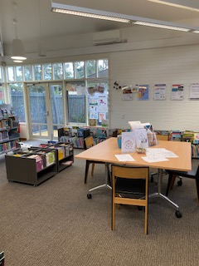  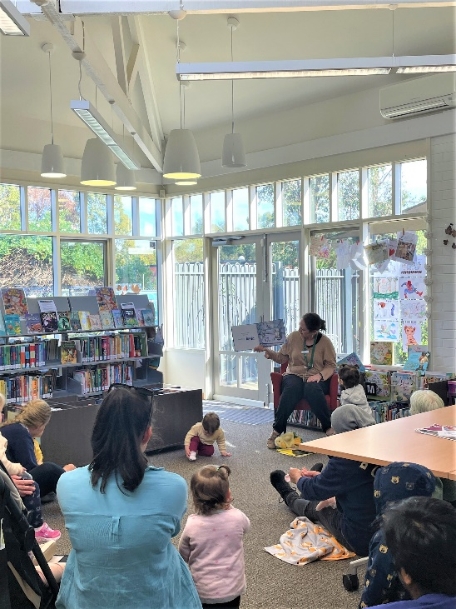
There may be a Storytime going on in the children’s library. It can be quite noisy with singing and dancing. Storytimes go for 30 minutes but families usually stay in the area for a while longer. You can go through the door to the right and into a small courtyard where it is quiet. | 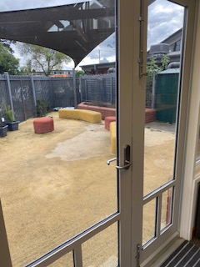
You can return your books at the return chute. If you place them in there, the library staff will later collect them | 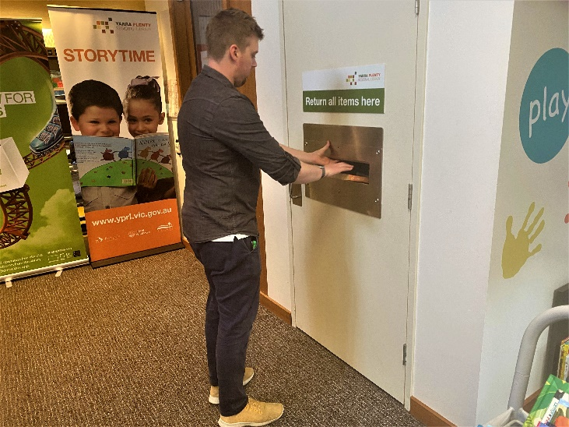
You may like to choose some books to borrow. You can use the self-check out machine to do this. If you have trouble, you can ask the library staff to help you. | 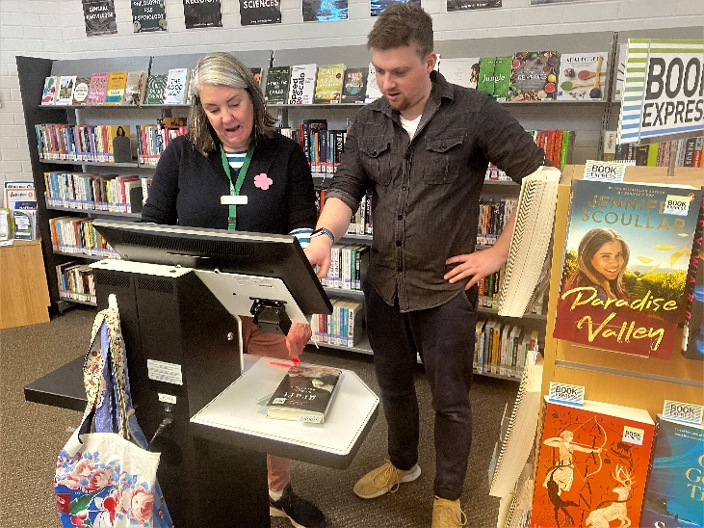
There are some boomerang bags in the library for you to borrow. They can be useful to carry your books. You can borrow these bags for as long as you like. | 