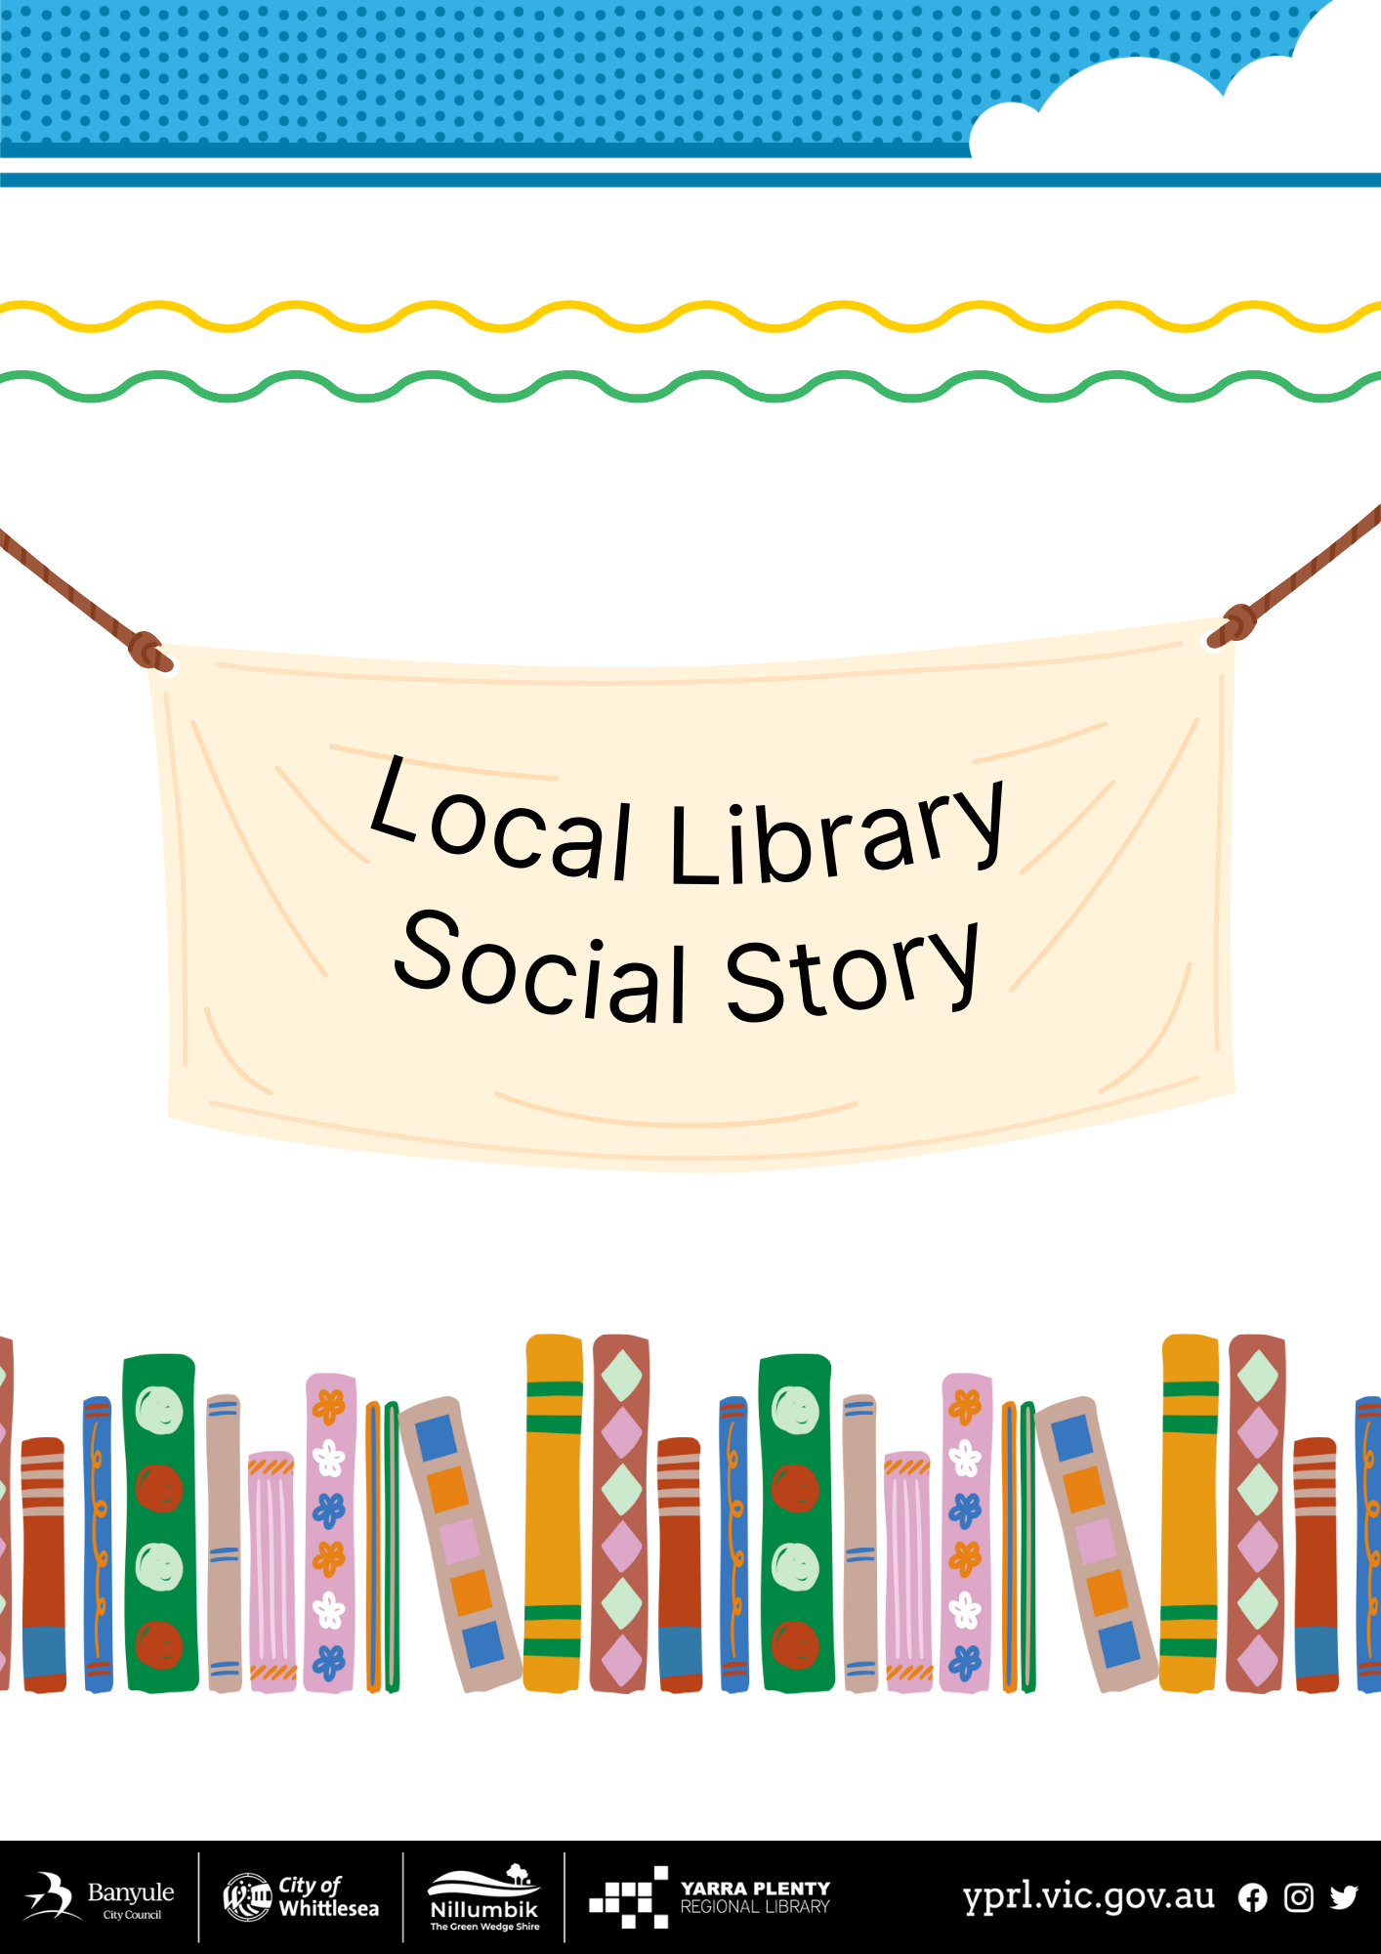
Social Story – My Visit to Diamond Valley Library

I am going to visit the Diamond Valley Library. | 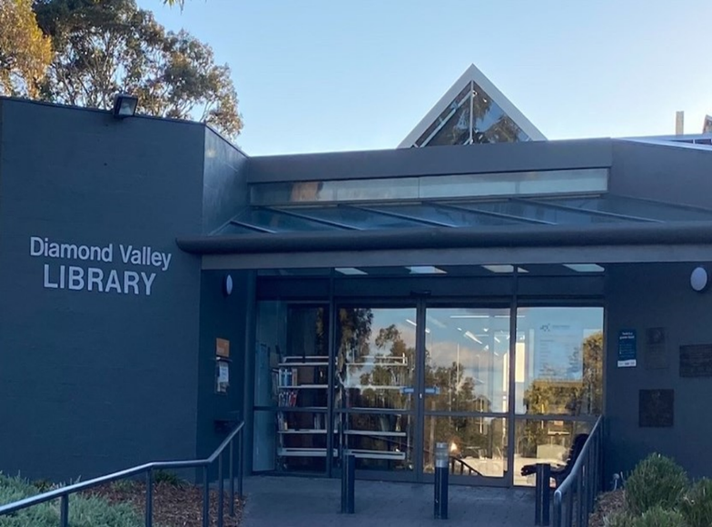
The door will open automatically when I get close. | 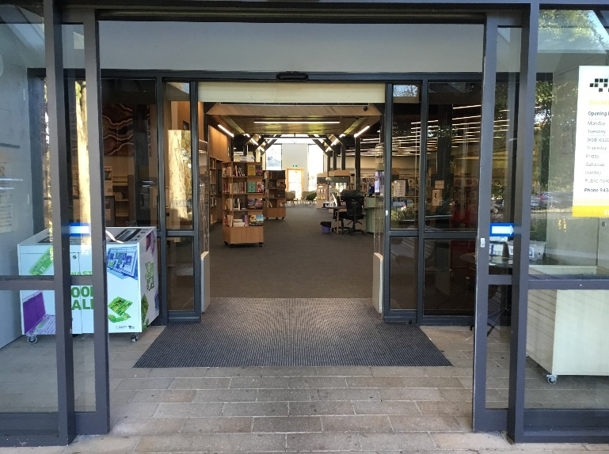
There are Public Toilets. | 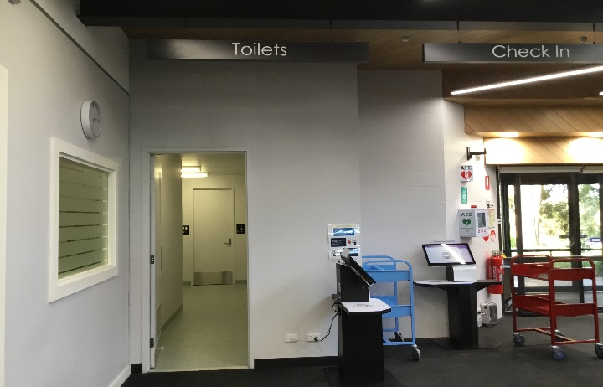
I can return my books before I come into the Library or when I’m inside the Library | 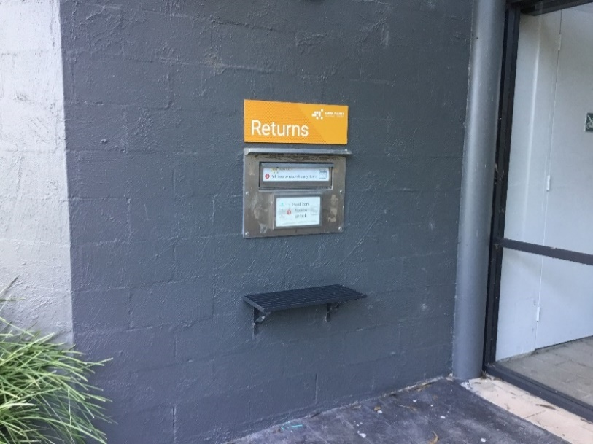  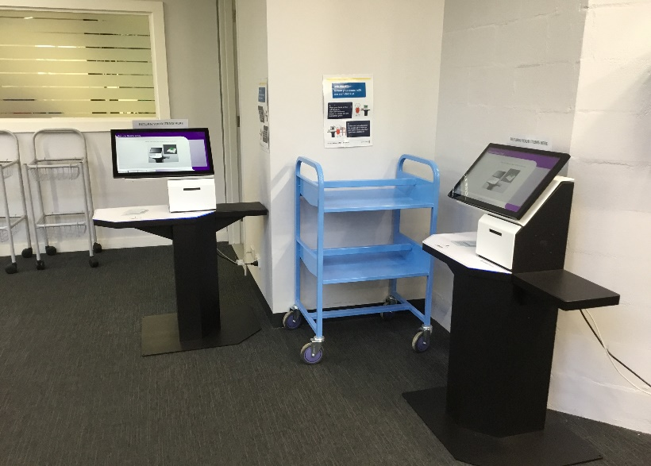
I can go to the information desk if I have any questions. | 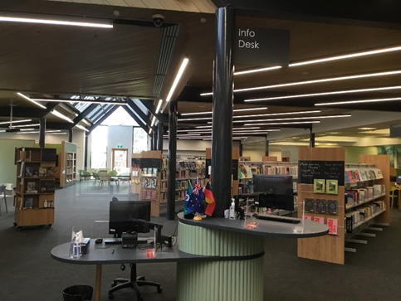
The librarians wear nametags, they can help me. | 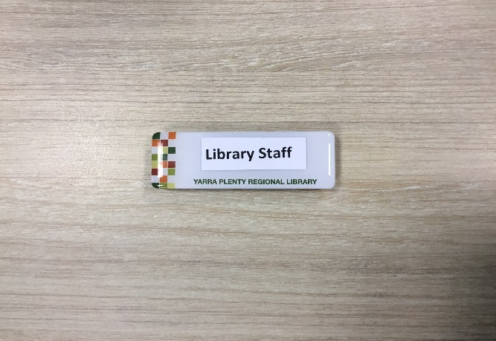
I can join the library at the information desk and get my own library card. | 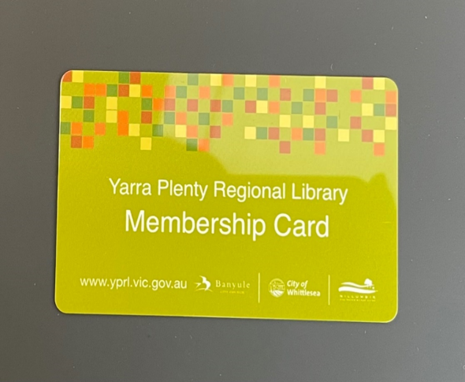
Books on reserve for people are on the left-hand side of the library. They will have a slip of paper with my name on it. | 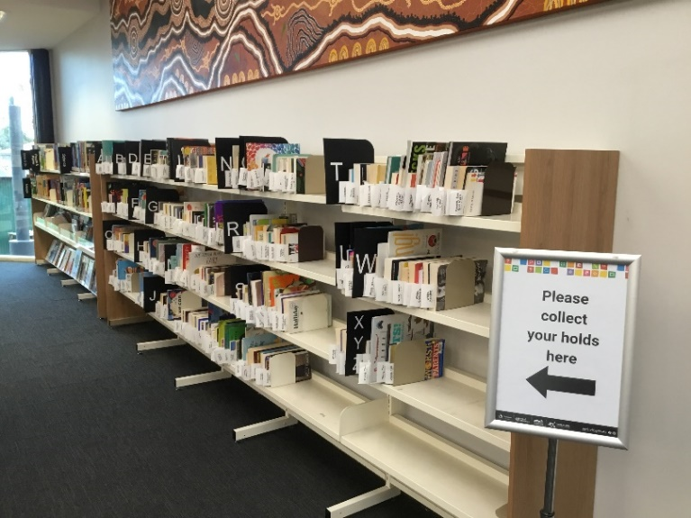
There are some shelves at the front of the library with new and popular books. | 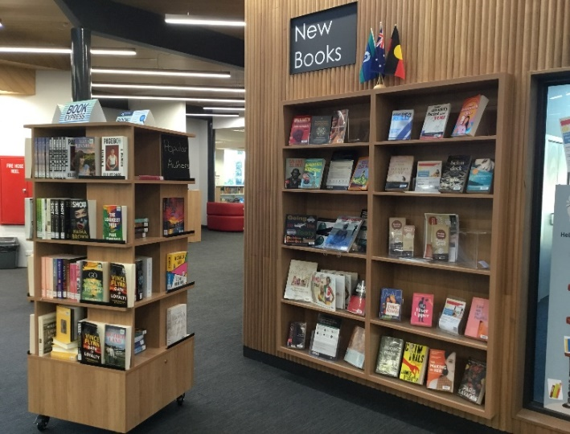
There is a photocopier in the library for people to print, photocopy and scan. It can be noisy when in operation. | 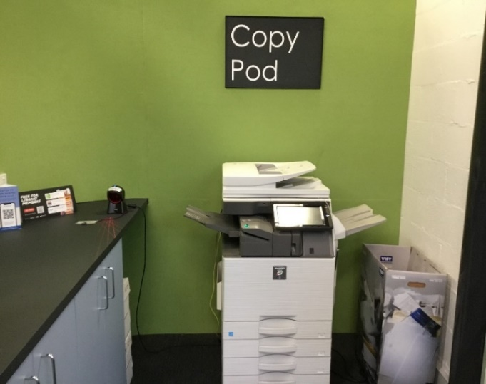
There are public computers that people can use to access the internet. | 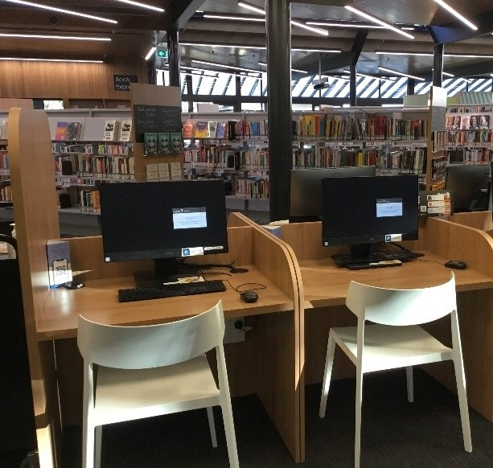
There is free Library Public Wi-fi that I can use to access the internet on my own device.
There are some tables and chairs at the back of the library. I can sit quietly and read here.  There are today’s newspapers as well. | 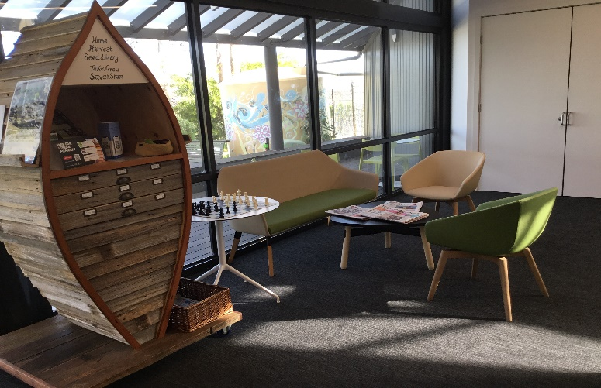
I can borrow items myself from the self-checkout machine. | 