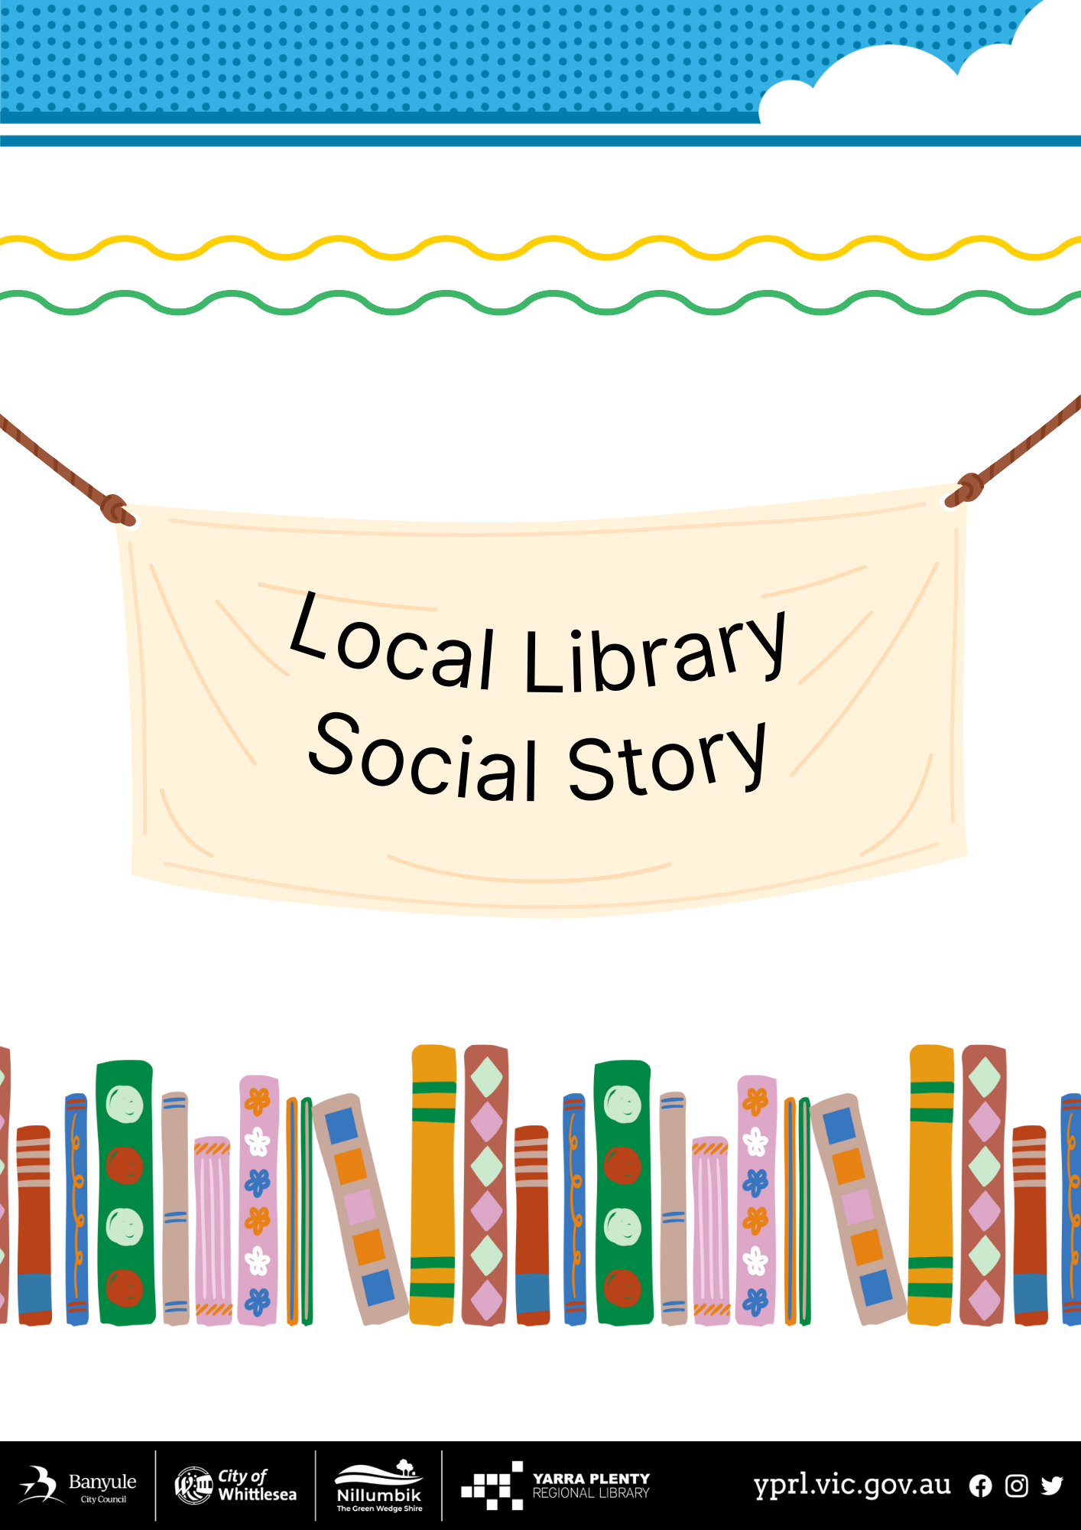
Eltham Social Story – A Visit to Eltham Library
I am going to visit Eltham library today. There is an access ramp that wraps around the building. | 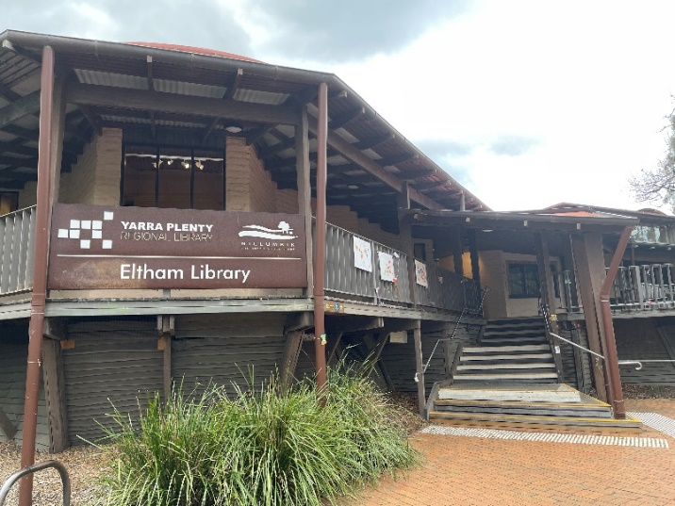
There is an after-hours chute for book returns on the right hand side of the entrance. | 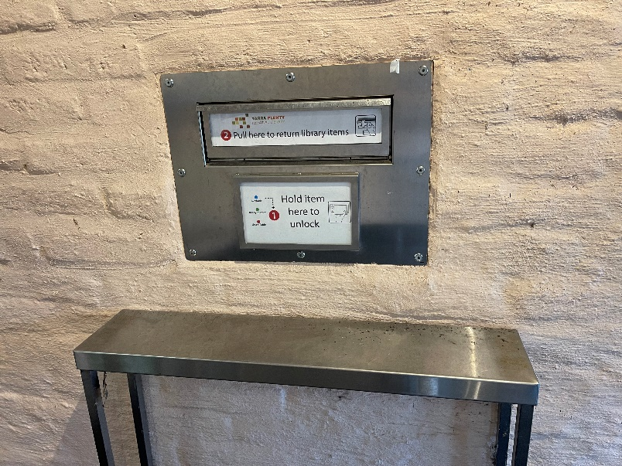
When I walk inside the automatic doors, I will see a gallery space. There are usually artworks hung on the wall. The library entrance is at the top of the stairs. There is another access ramp here that goes along the walls to the left. | 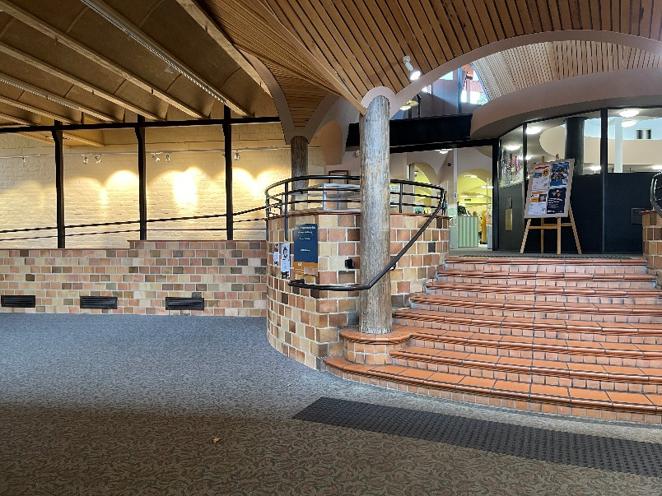
Public toilets are down the corridor to the right of the stairs. These toilets are female, male and accessible/family change. | 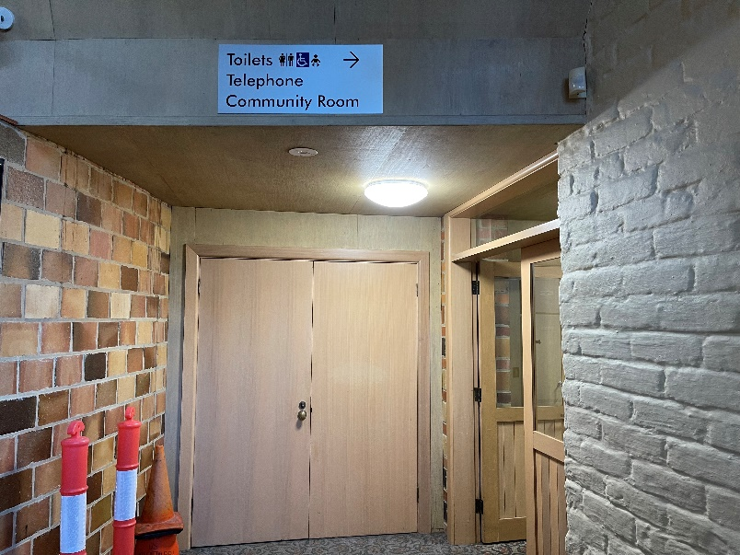
To return books I can put them through the wall chute as I enter the library.
I will pass through the security gates, and they may beep and light up red if I have a library item. Staff are happy to help if this happens. | 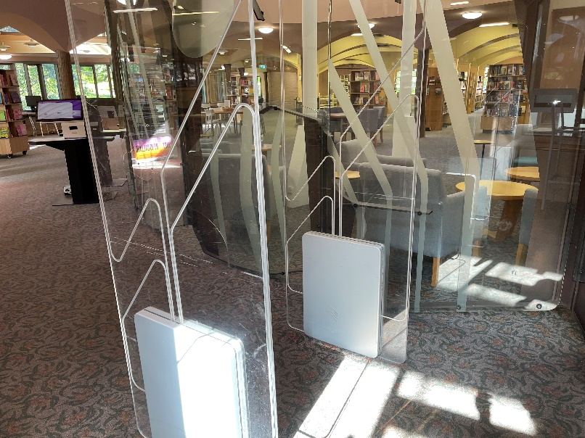
A librarian can help me at the front desk. I can ask questions here or become a library member. If I require communication tools, I can request these, too. | 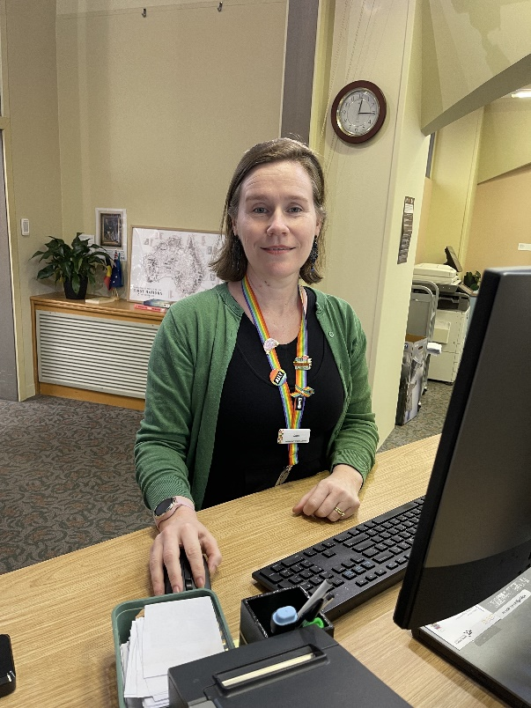
There is a printing area near the front desk. The catalogue computer can help you find the books you want to borrow. | 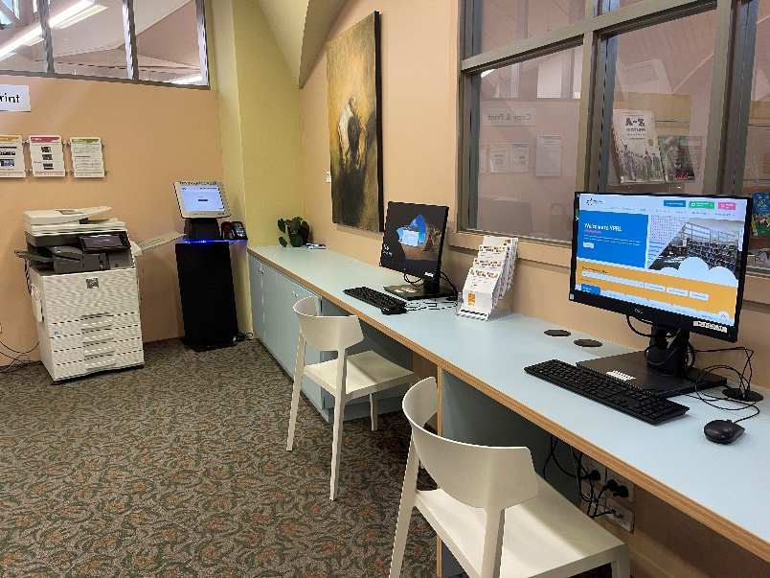
I can also access public computers. We have a high-vis keyboard and mouse available by request. | 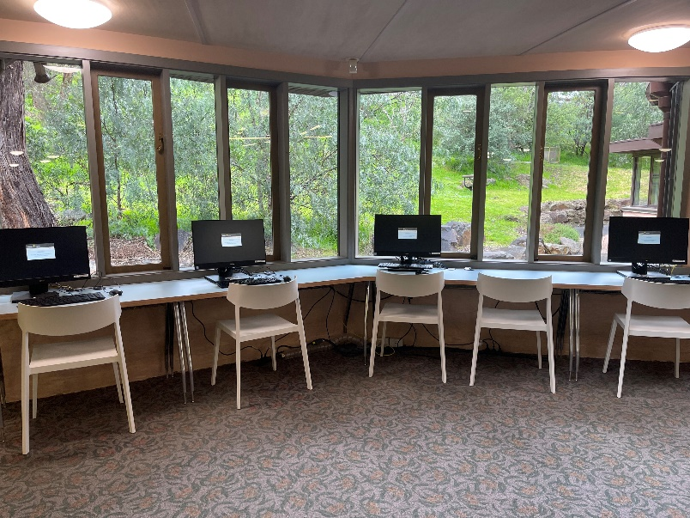
I can sit by the fire with a book to read and a cup of herbal tea. | 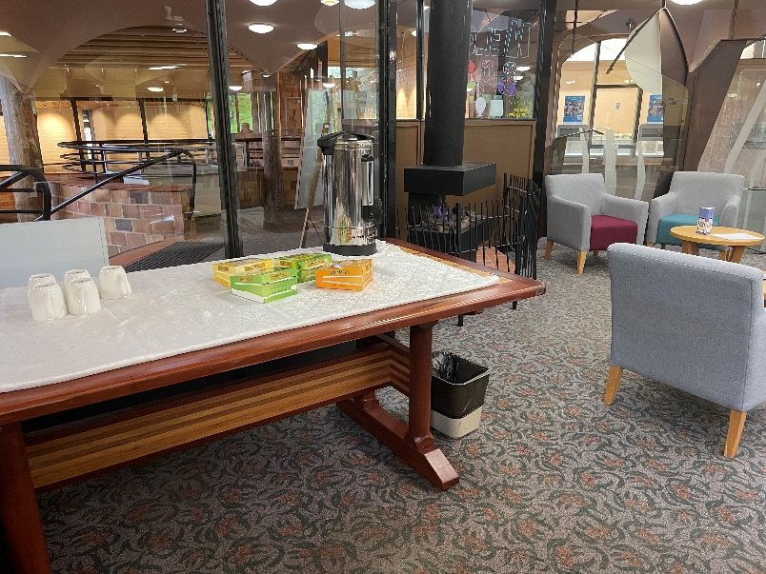
The children’s area can get very busy and sometimes noisy during storytimes. An accessible toilet and change table are on the left as I enter this space. | 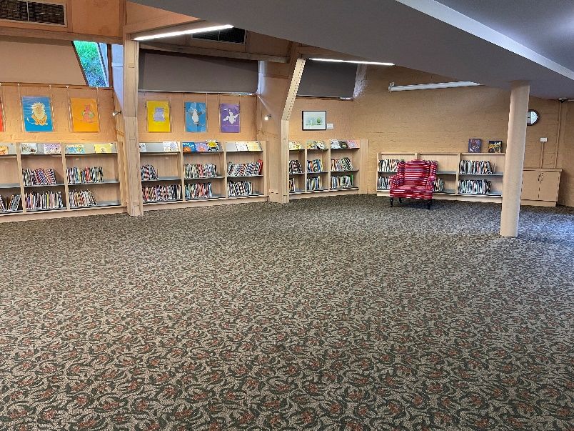
The entrance to the garden can be found at the children’s area if I want to go outside. Water taps are available here. | 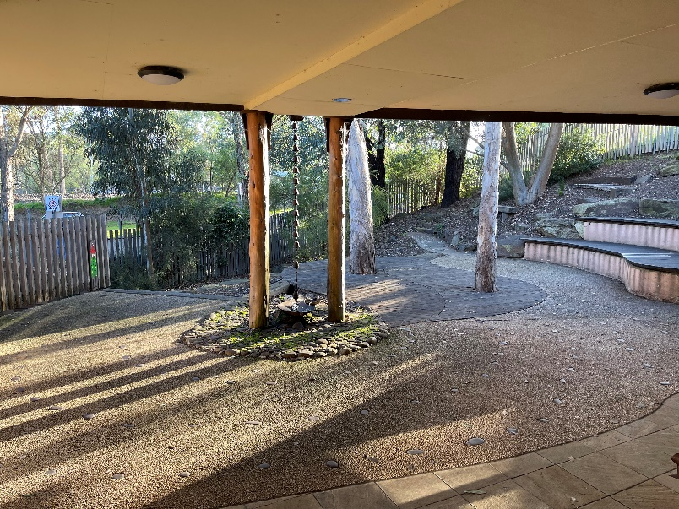
Reservations for patrons can be collected from a special area. | 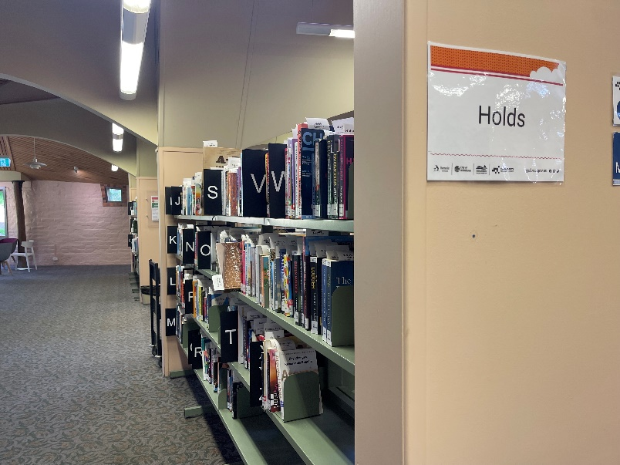
There are lots of shelves of books to browse. | 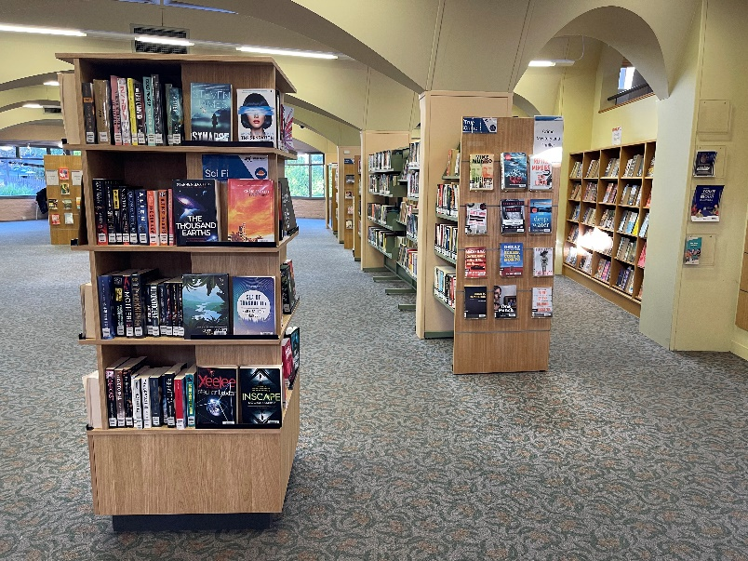
There are lots of study areas, too. | 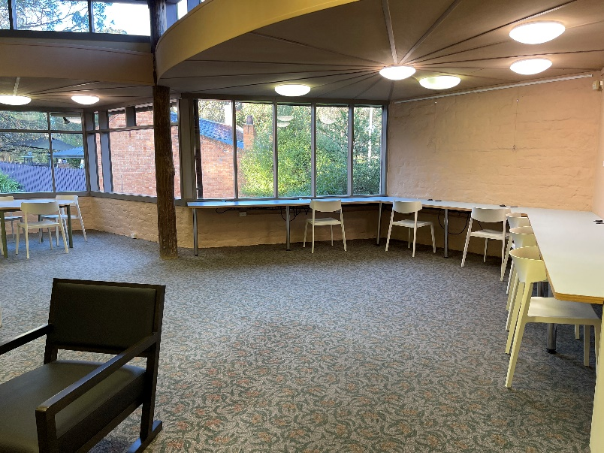
There is a quiet study area upstairs but can only be accessed by steps. | 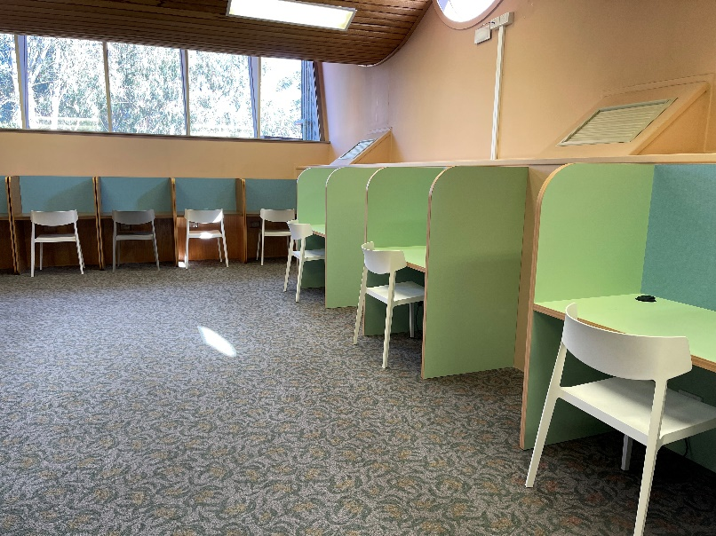
I can check out my own books at the self-serve kiosk. | 