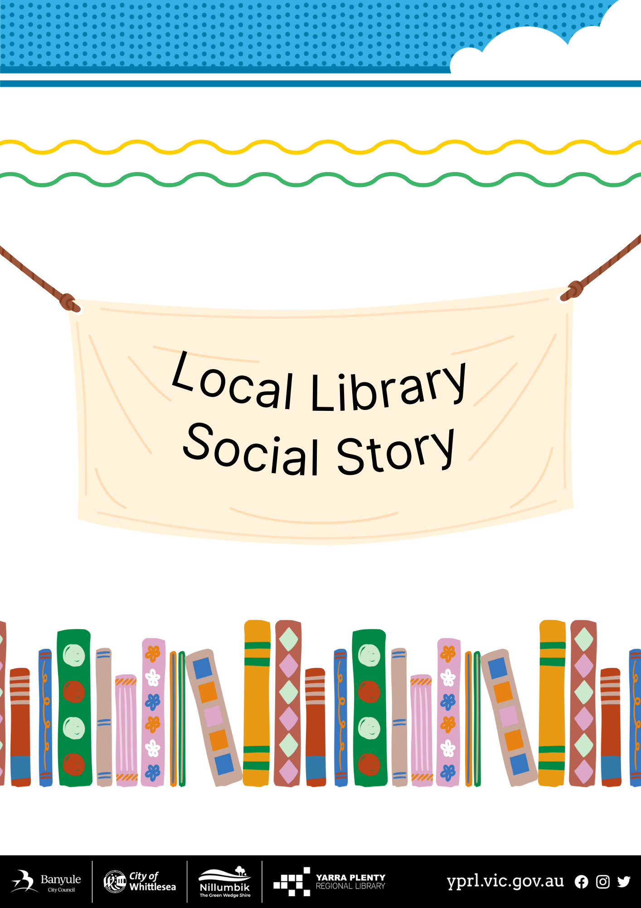

Social Story – My Visit to Mernda Library

I am going to visit the Mernda Library. | 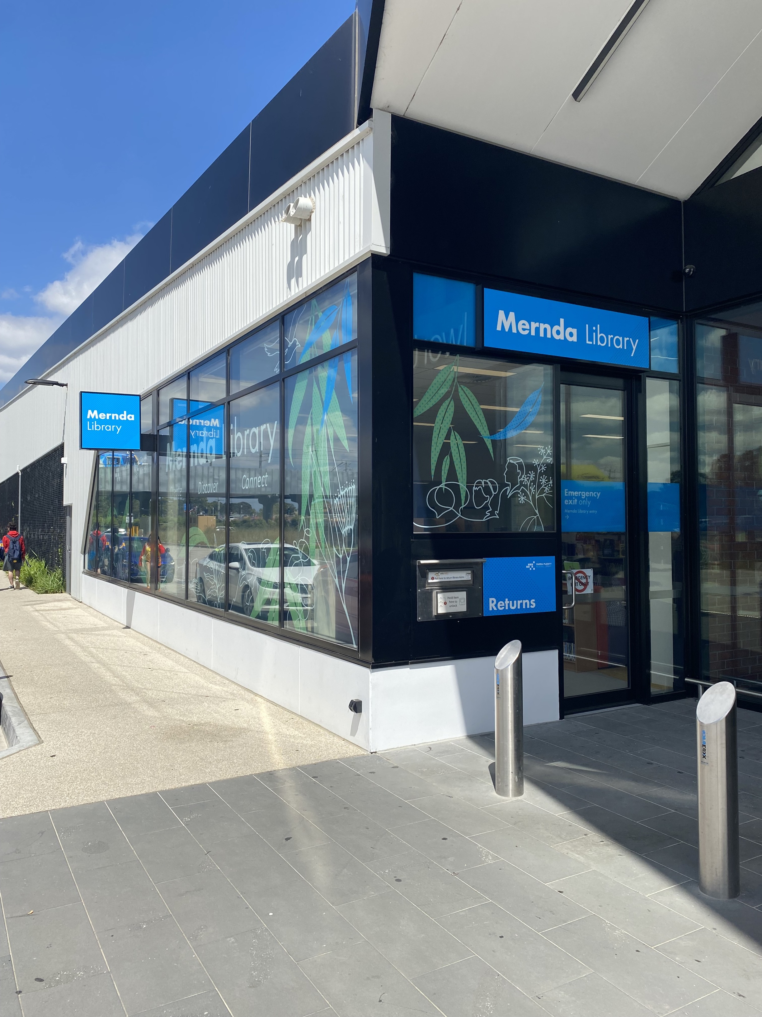
I will get to the library by entering the shopping centre first | 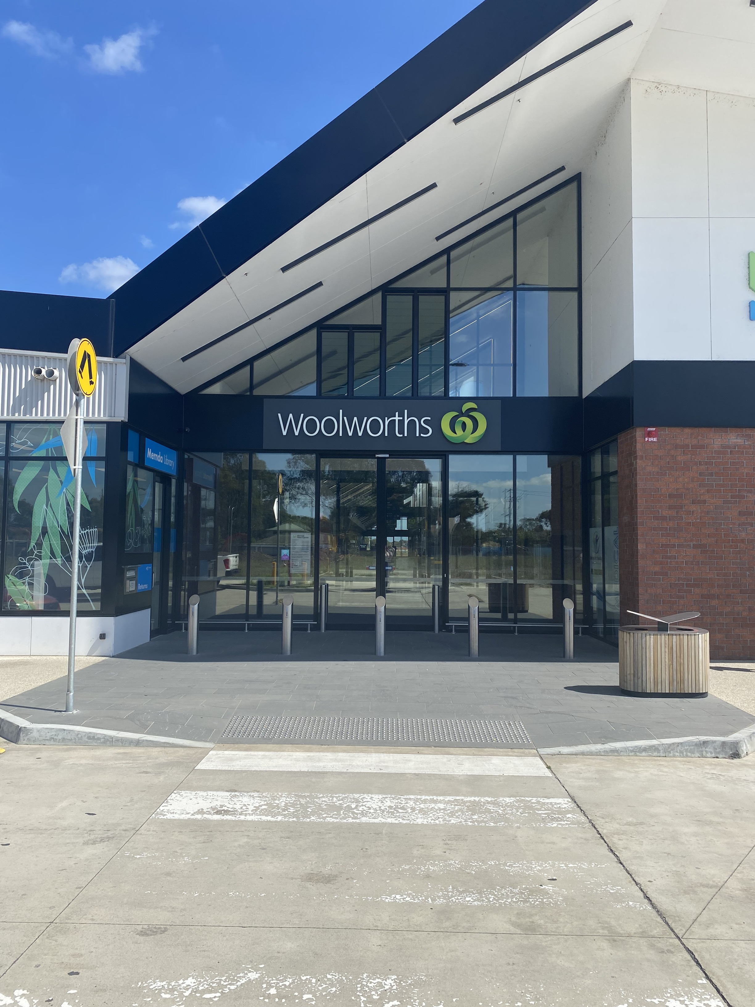
Then I will enter through the automatic doors next to the fruit and vegetable shop | 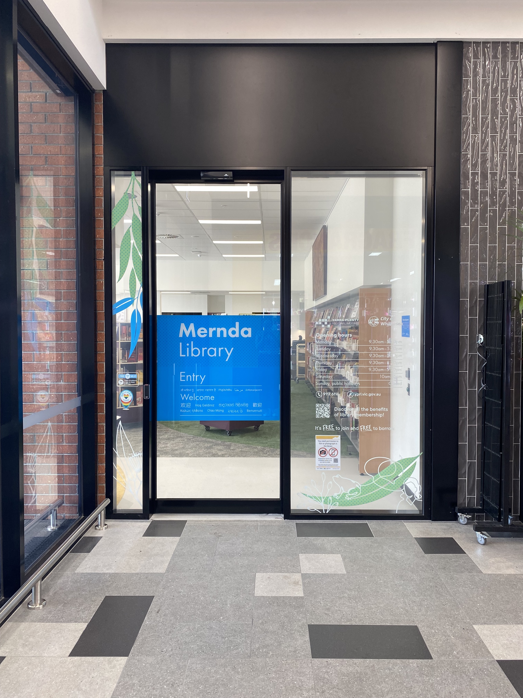
I can return my books before I come into the library by using the chute outside. | 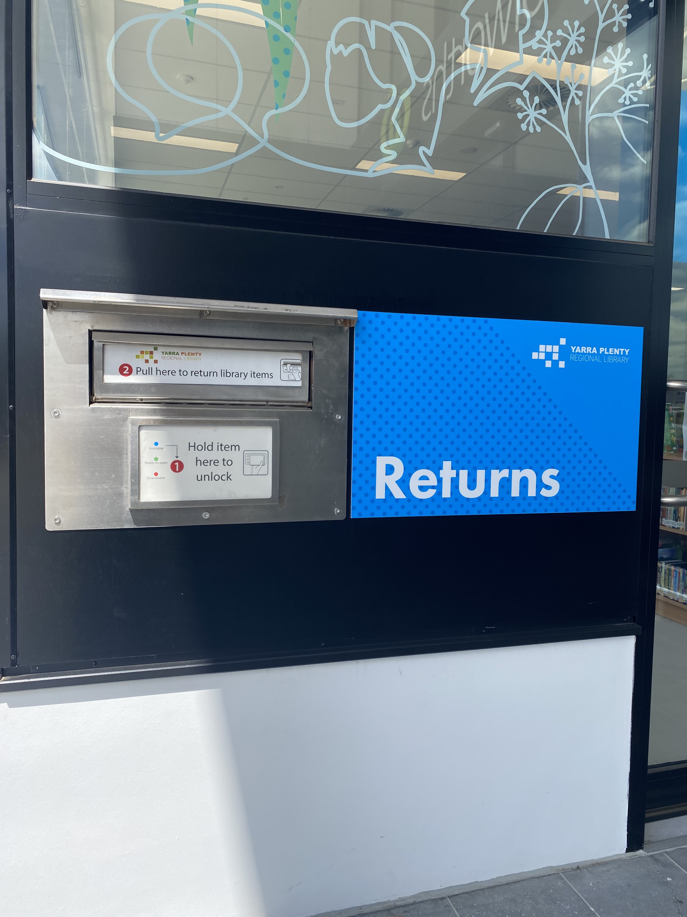
I can find books, comics, DVDs and audiobooks on the shelves | 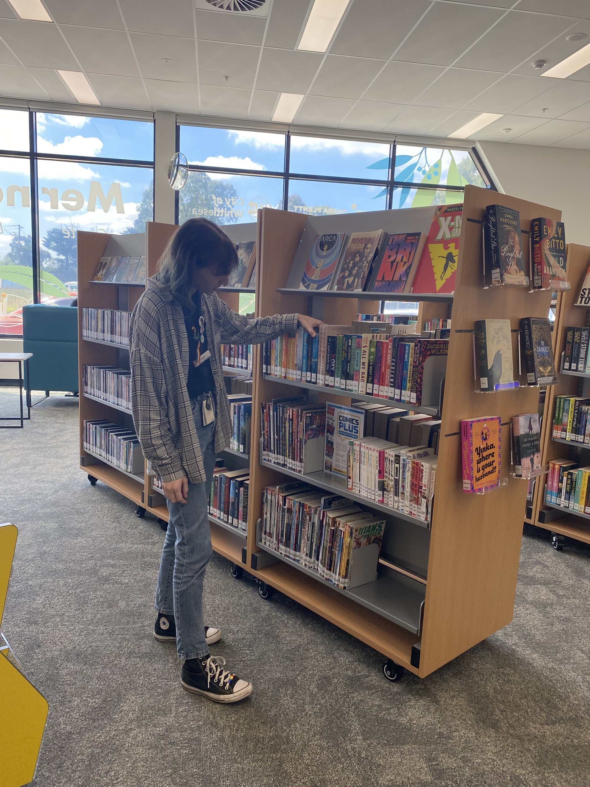
If I am coming to pick up a reservation, I can find it at the front of the library on the righthand side when I first walk in | 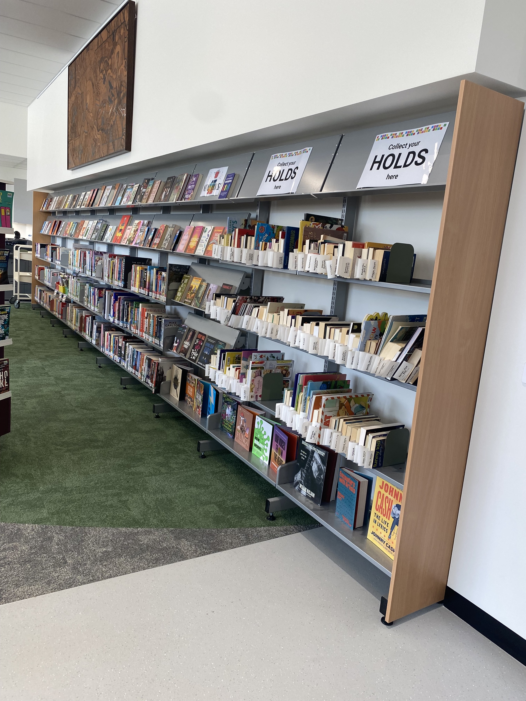
I can go to the information desk if I need to ask the librarians a question. | 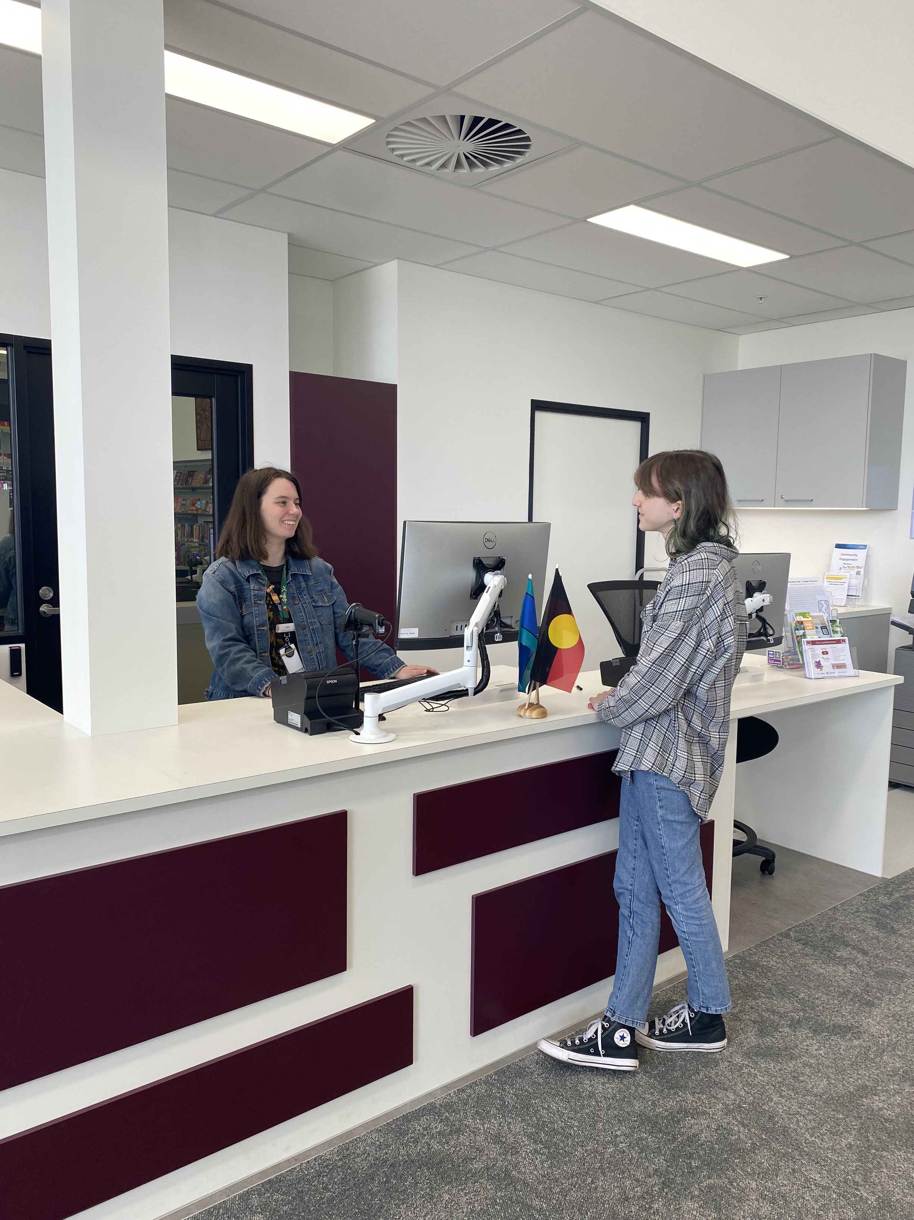
I can join the library online or at the information desk and get my own library account. | 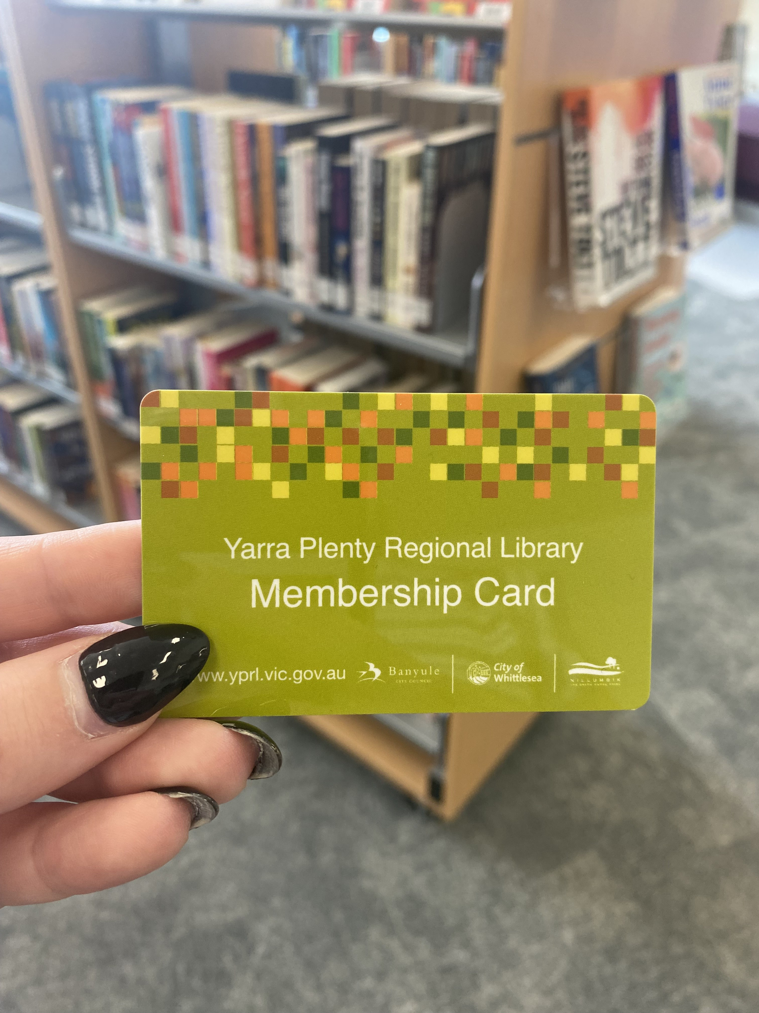
I can use my library number to log onto the public computers. | 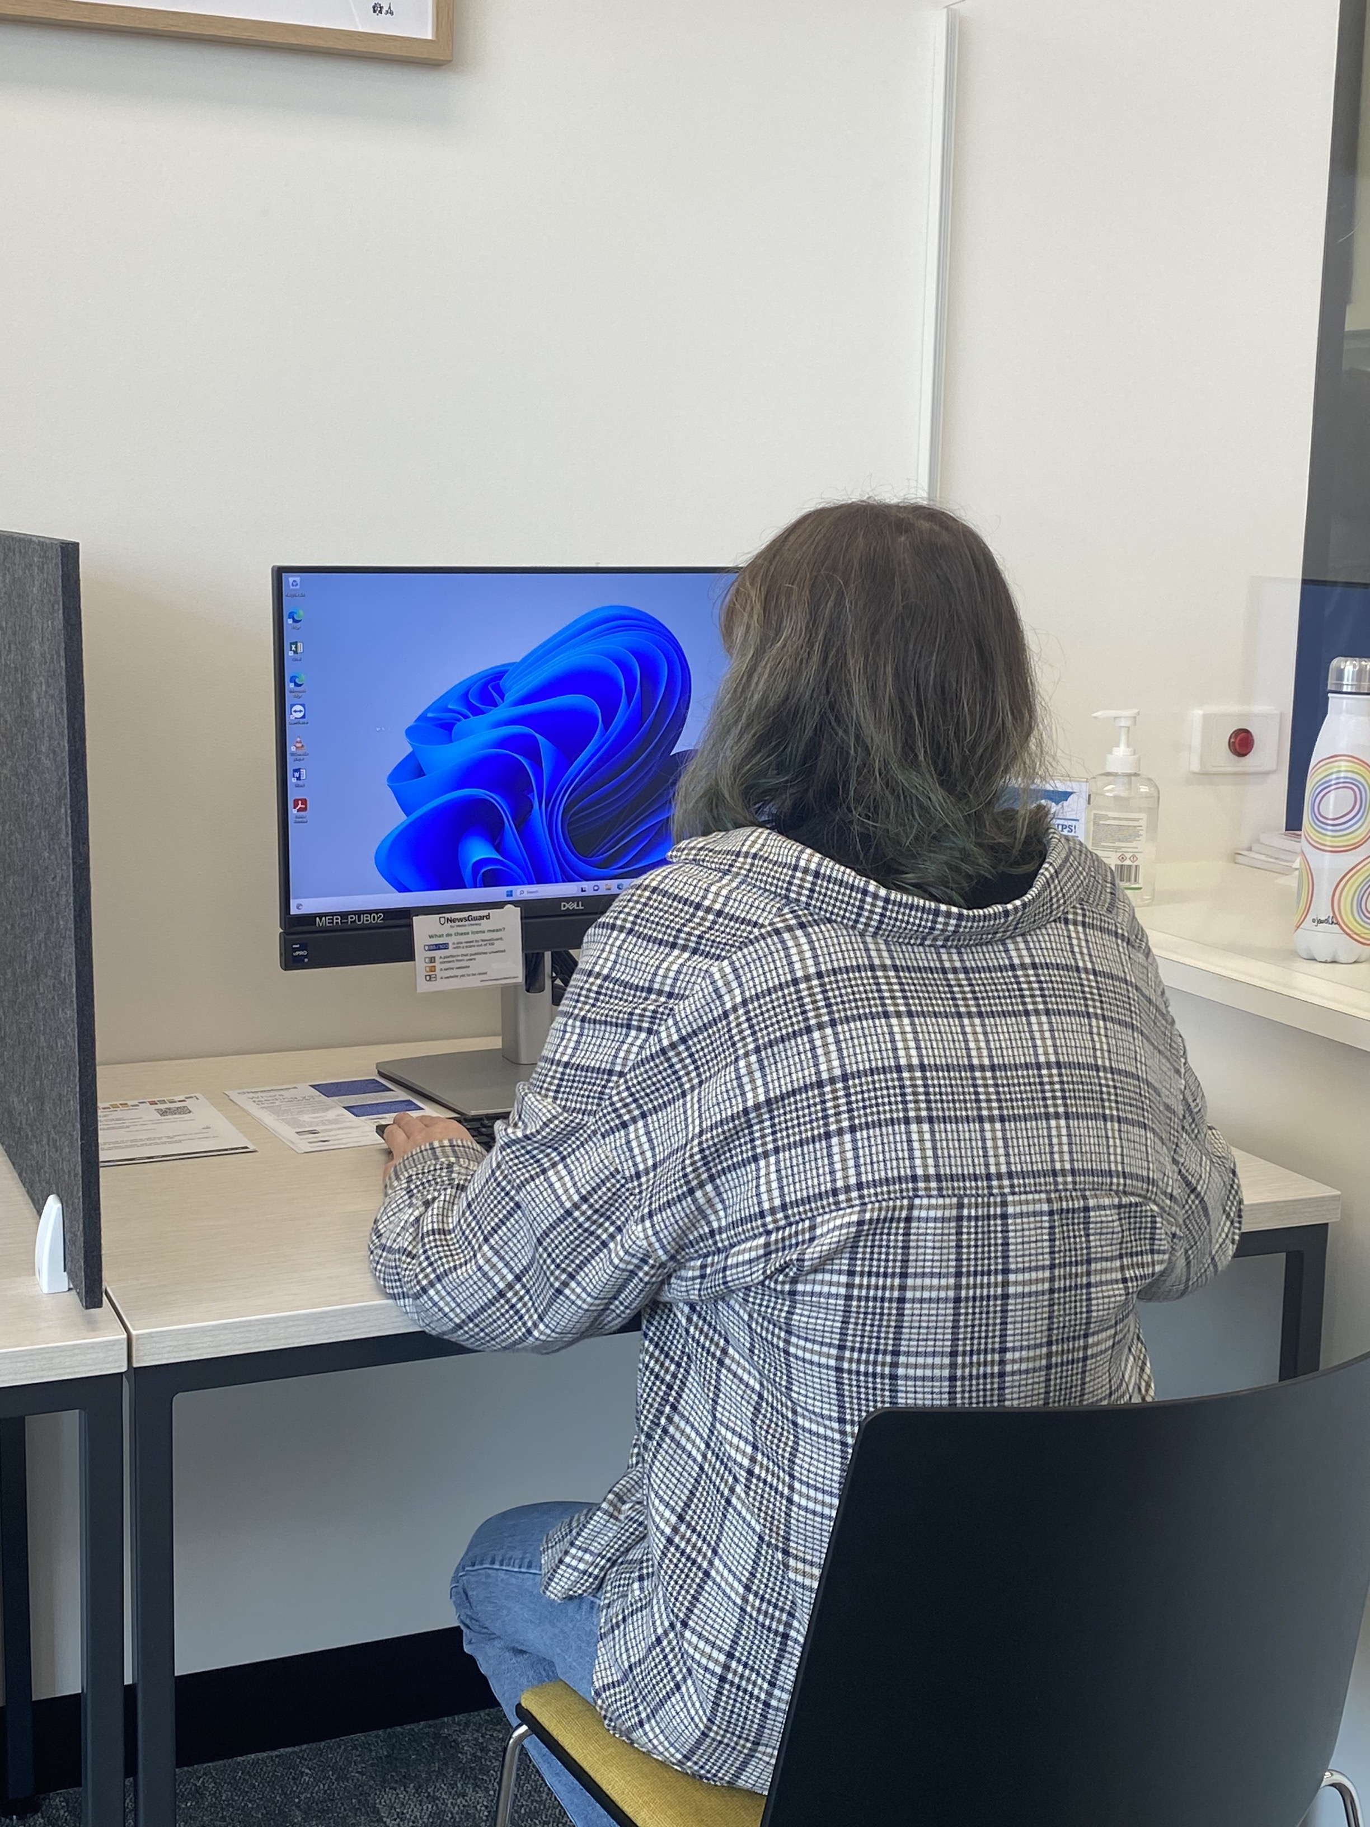
I can use my library number to access the printer. I can print, scan, or copy things. The librarians can help me if I’m unsure how to use the printer. | 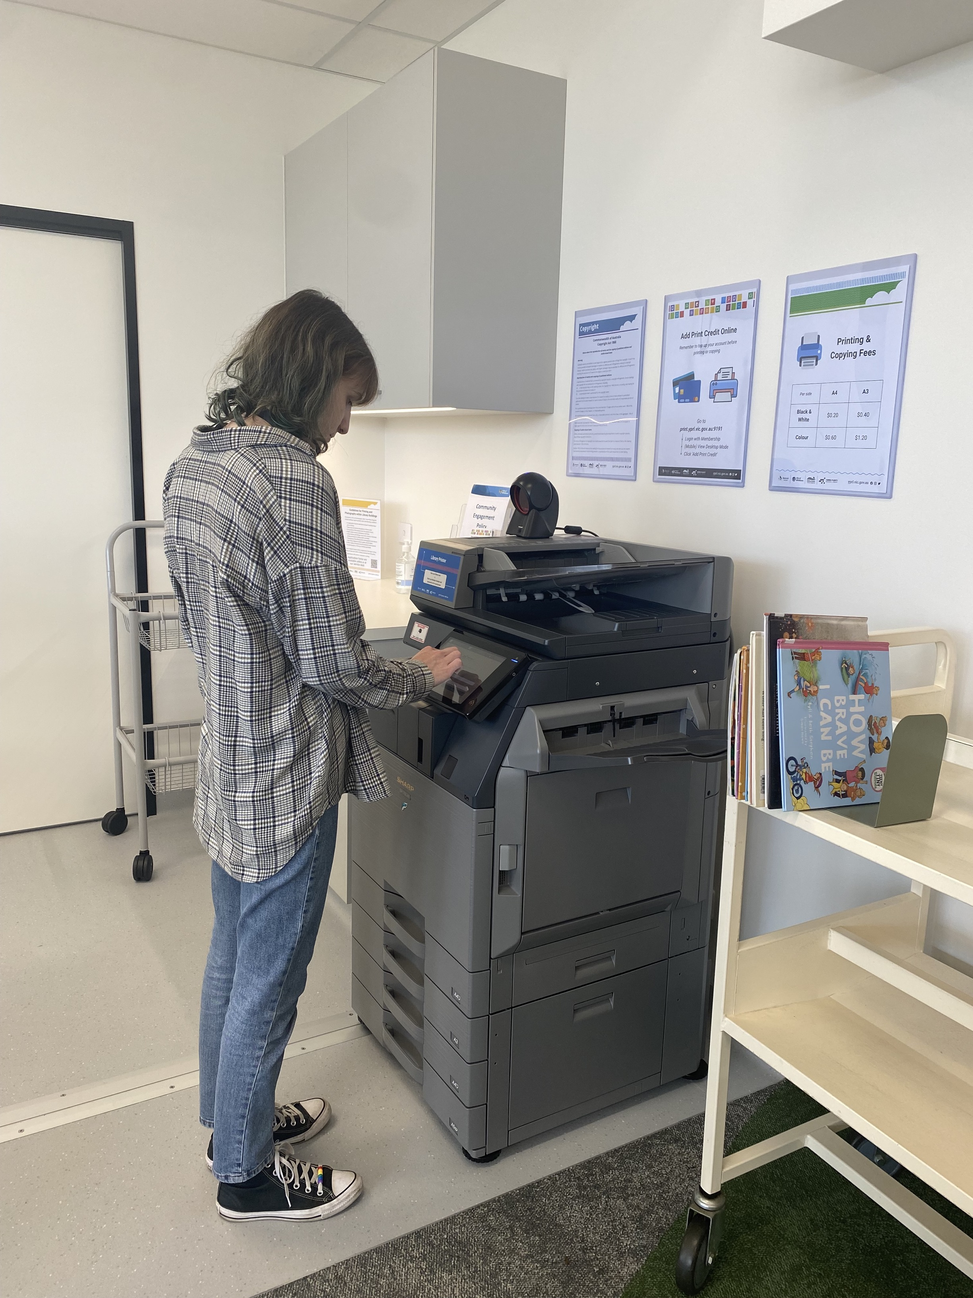
I can sit in the chairs or study spaces to do quiet activities | 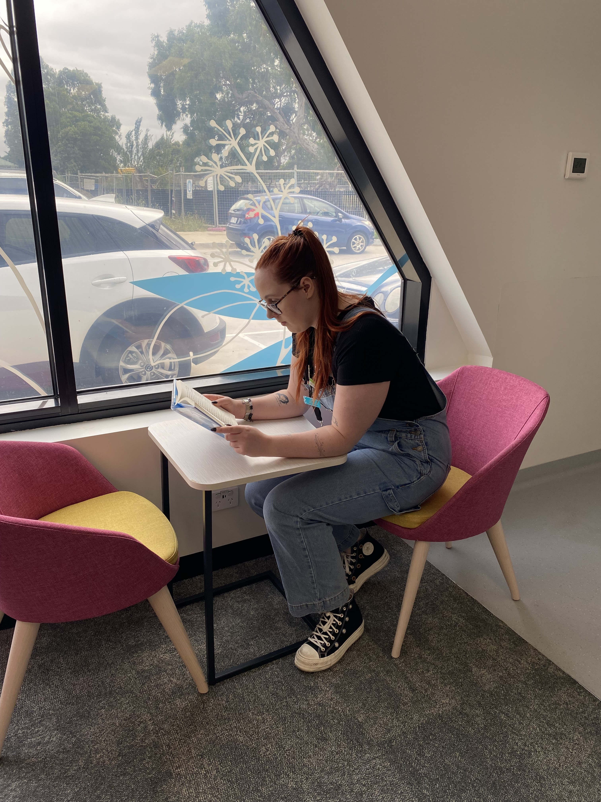
There is a toilet towards the back of the library that I can use | 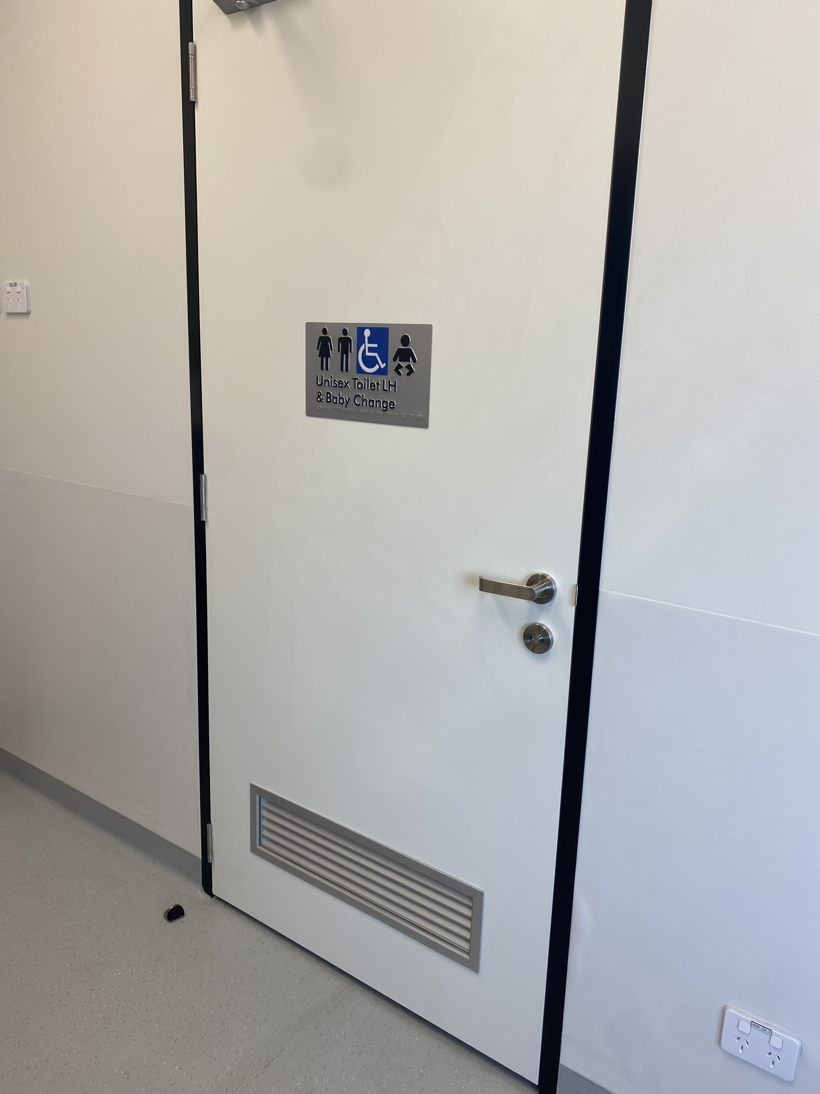
I can borrow items myself from the self-checkout machine. | 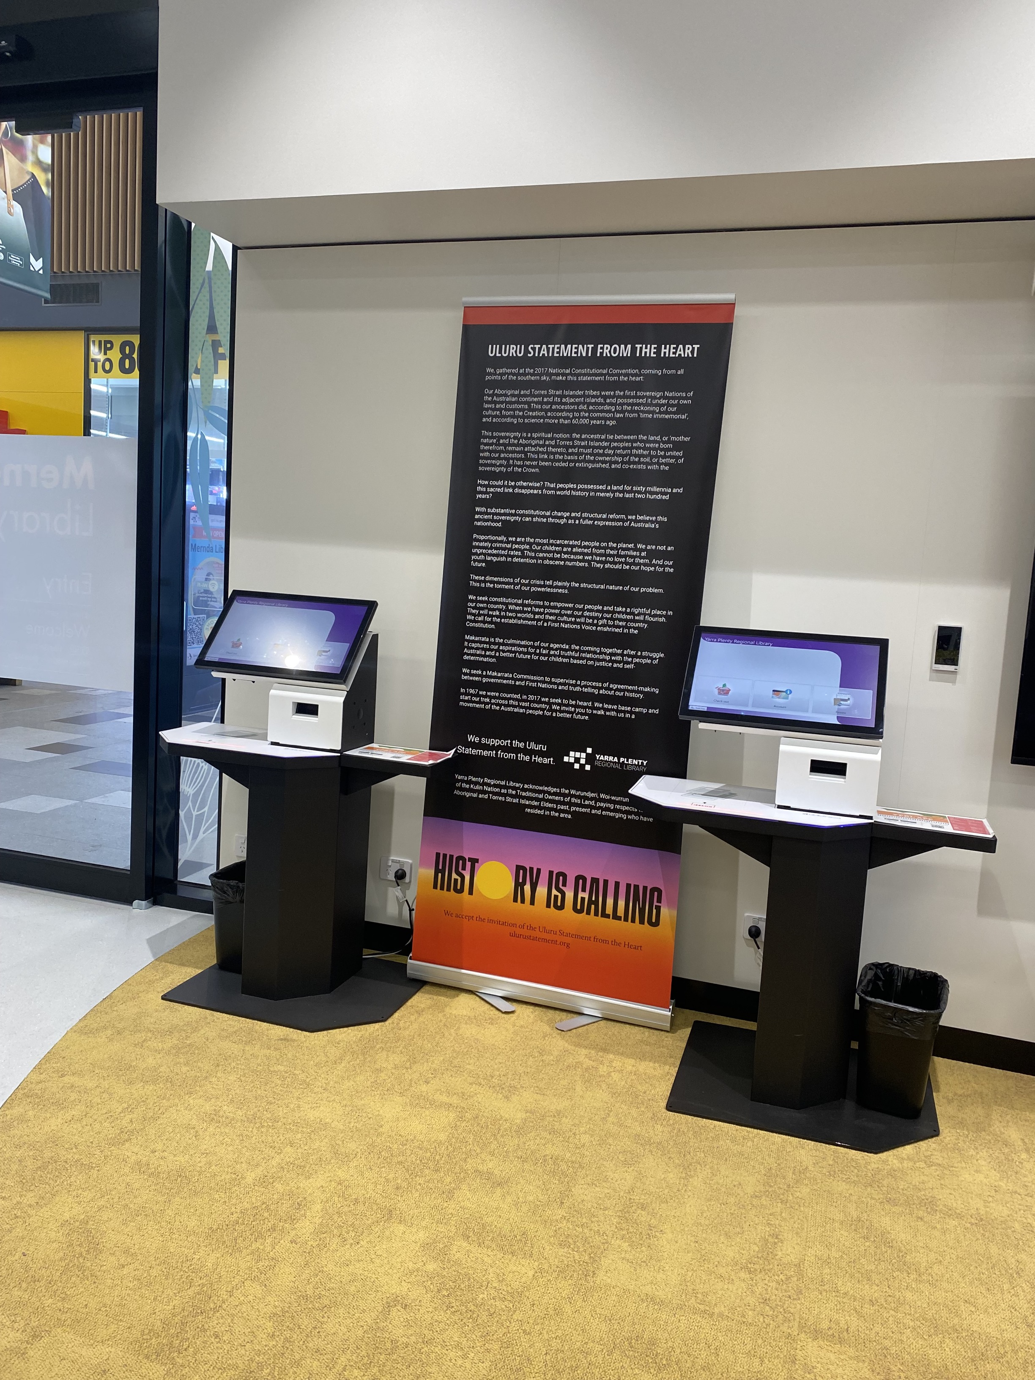
When I’m ready to leave, I can exit through the same door I came in from | 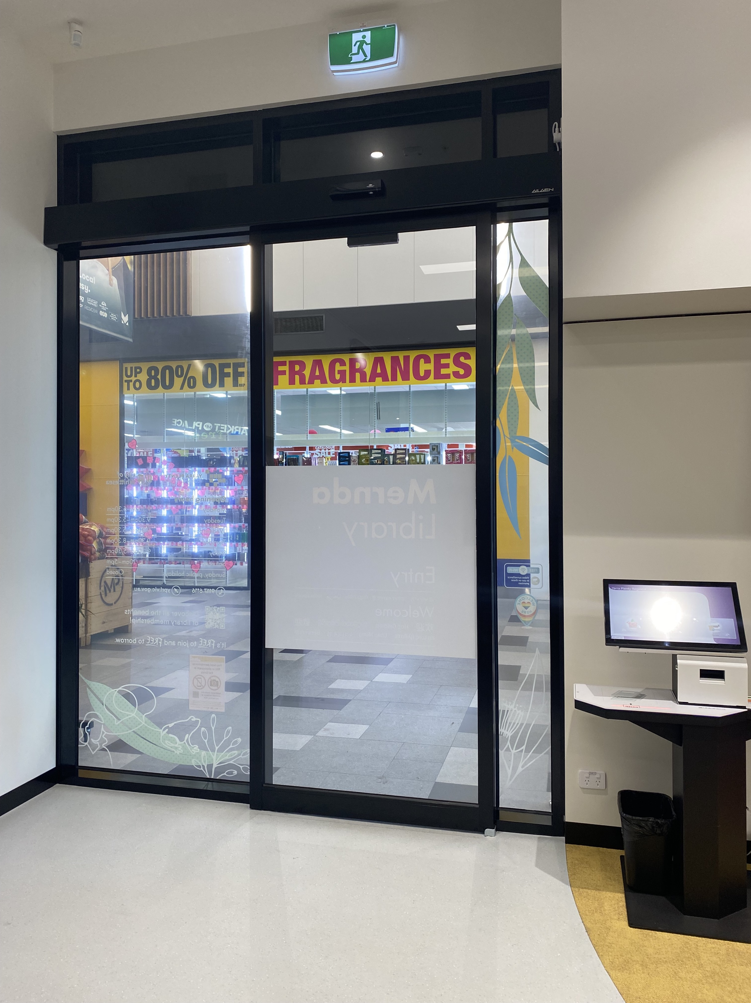
I won’t exit from the emergency exit door, because it will make a very loud alarm noise if I open it | 